# Abstract

This project report investigates the integration of ModSecurity, a robust Web Application Firewall (WAF), with the Nginx server to enhance cybersecurity measures for web applications. The primary objective is to evaluate the effectiveness of ModSecurity, including the implementation of the OWASP Core Rule Set (CRS), in mitigating common web-based attacks, particularly SQL injection and cross-site scripting (XSS). The methodology involves configuring ModSecurity to work seamlessly with Nginx, enabling comprehensive logging features, and testing it against various attack scenarios. Key findings indicate that ModSecurity, coupled with the OWASP CRS and detailed logging, significantly improves the security posture of web applications by effectively detecting and blocking malicious traffic while providing valuable insights through logs. The report concludes with recommendations for further optimization and highlights the importance of continuous security monitoring and detailed logging for proactive threat management.

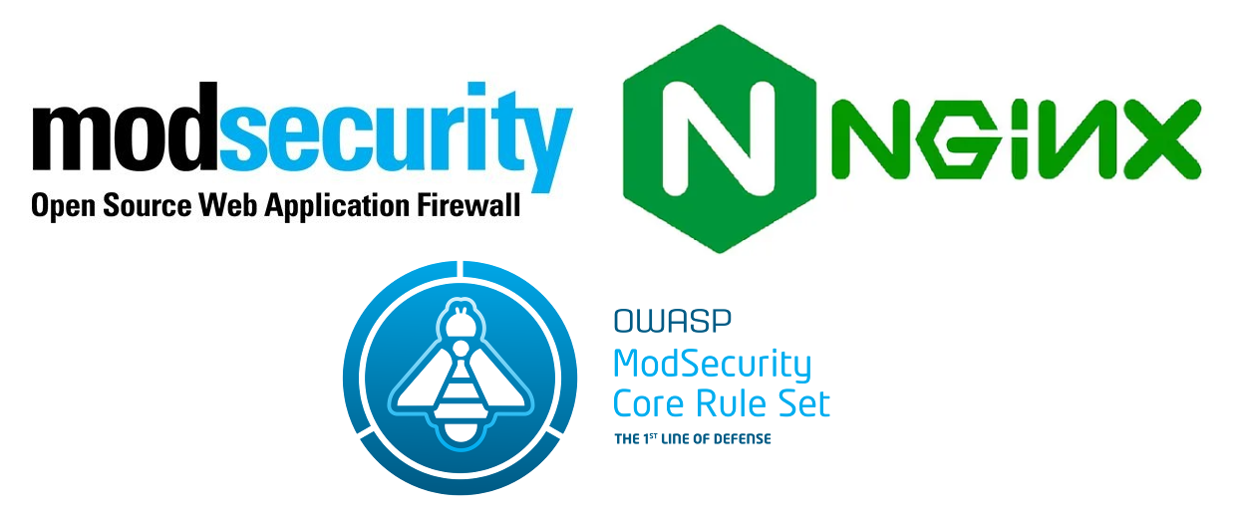

Figure components

# Table of contents

Abstract 2

Table of contents 3

Table of Figures 4

1.Introduction 6

1. Overview of the Project and Objectives: 6

2. Importance of Implementing Defense Security Solutions: 6

3. Report Structure: 6

2.Product Presentation 7

1. ModSecurity: 7

2. Features, Functionalities, and Capabilities: 8

3. Why ModSecurity? 9

3.Attack Scenarios on Security Solutions 11

SQL injection attack 11

1. Methodology: 11

2. Impact: 11

3. Launch Method: 11

4. Evidence: 11

URL SQL Injection 12

1. Methodology: 12

2. Impact: 12

3. Launch Method: 13

4. Evidence: 13

XXS attack 14

1. Methodology: 14

2. Impact: 14

3. Launch Method: 14

4. Evidence: 14

Methodology: 15

Impact: 15

Launch Method: 15

Evidence: 15

4.Results of the Scenarios 17

References 20

Netnea's Nginx Tutorials: 20

OWASP ModSecurity Core Rule Set: 20

Medium Article on Nginx: 20

Namecheap Knowledgebase Article on ModSecurity: 20

Wikipedia Page on ModSecurity: 20

OWASP ModSecurity GitHub Repository: 20

Nginx Official Download Page: 20

Appendix 21

1. Compiling NGINX 21

Step 1: Preparing the directory tree for the source code 21

Step 2: Meeting the requirements for NGINX 21

Step 3: Downloading the source code and verifying the integrity of the code 21

Step 4: Unpacking and configuring the compiler 22

Step 5: Compile the nginx server 23

Step 6: Installing 24

Step 7: Starting nginx 24

Step 8: Inspecting the server’s binary and related libraries 25

2. NGINX Configuration 25

Step 1: Creating a minimal configuration 25

Step 2: Starting and testing the server 26

3. Embedding ModSecurity 27

Step 1: Downloading the source code and verifying the checksum 27

Step 2: Unpacking and configuring the compiler 28

Step 3: Compiling and installing standalone ModSecurity 30

Step 4: Compiling the connector module 31

Step 5: Creating the base configuration 34

4. Include OWASP ModSecurity Core Rule Set v3 40

Step 1: Download the source 40

Step 2: Include CRS rules 40

# Table of Figures

Figure 1 components 2

Figure 2 ModSecurity integrated with Nginx 8

Figure 3 Nginx with ModSecurity workflow 10

Figure 4 SQLi attack 11

Figure 5 WAF response to SQL injection attack 12

Figure 6 SQL Injection logs 12

Figure 7 SQL injection attack 2 13

Figure 8 WAF response to URL SQL injection 13

Figure 9 SQLi through url logs 14

Figure 10 WAF response to XSS attack 14

Figure 11 XSS logs 15

Figure 12 blacklist rule 15

Figure 13 blacklist logs 16

# 1.Introduction

## Overview of the Project and Objectives:

In an era where cyber threats are becoming increasingly sophisticated and frequent, securing web applications is more critical than ever. This project aims to enhance cybersecurity by integrating ModSecurity, a robust Web Application Firewall (WAF), with the Nginx server. The primary objective is to safeguard web applications from a myriad of attacks, particularly those listed in the OWASP Top Ten, such as SQL injection, cross-site scripting (XSS), and denial of service. By implementing this solution, we aim to demonstrate how effective WAFs can be in protecting web applications from both common and advanced threats.

## Importance of Implementing Defense Security Solutions:

Web applications are often the target of cyber-attacks due to their accessibility and the valuable data they hold. Implementing defense security solutions like ModSecurity WAF is essential for several reasons:

* Protection Against Common Vulnerabilities: ModSecurity helps mitigate risks associated with common vulnerabilities such as SQL injection and XSS, ensuring that the application is more secure against these types of attacks.
* Compliance with Security Standards: Utilizing a WAF aids in achieving compliance with various security standards and regulations, which often mandate protective measures against web application attacks.
* Enhanced Monitoring and Logging: ModSecurity provides extensive logging capabilities, allowing for better monitoring of web traffic and detection of suspicious activities.
* Layered Security Approach: Adding a WAF to the security architecture introduces an additional layer of defense, making it more difficult for attackers to breach the system.

## Report Structure:

This report is structured to provide a comprehensive overview of the project, detailing each phase from conceptualization to implementation and analysis:

1. Product Presentation: This section introduces ModSecurity WAF, detailing its features, functionalities, and capabilities. It explains why this particular solution was chosen and includes visual aids or diagrams to enhance understanding.
2. Attack Scenarios on Security Solutions: This section describes various attack scenarios relevant to ModSecurity WAF. It explains the methodology of each attack, its potential impact, and includes real-world examples or case studies. Additionally, it details how the attacks were launched, the tools used, and provides evidence through screenshots.
3. Results of the Scenarios: Here, the report analyzes the performance of ModSecurity WAF against each attack scenario. It identifies any vulnerabilities or weaknesses observed during testing, discusses the effectiveness of the solution in mitigating attacks, and provides quantitative metrics or statistics to support the analysis.
4. Conclusion: The conclusion summarizes the key findings and observations from the report. It evaluates the effectiveness and efficiency of ModSecurity WAF, assesses the project's success in achieving its objectives, discusses any challenges faced and how they were overcome, and offers recommendations for further enhancements or areas of improvement.
5. References: This section provides proper citation of all sources referenced in the report.
6. Appendix: The appendix contains detailed instructions for installing, configuring, and deploying ModSecurity WAF, Nginx, and OWASP CRS. It includes screenshots, code snippets, command-line examples, and additional tips and guidance to aid understanding and implementation.

# 2.Product Presentation

## ModSecurity:

ModSecurity is an open-source web-based firewall application (WAF), when integrated with the Nginx web server and OWASP CRS, it forms a powerful defense layer against web application attacks. By blocking SQL Injection (SQLi), Remote Code Execution (RCE), Local File Include (LFI), cross‑site scripting (XSS), denial of service (DOS), and many other attacks. It acts as an intermediary between the user and the web application, inspecting incoming traffic, detecting malicious patterns, and taking appropriate actions to mitigate potential attacks along with logging feature to inspect any upcoming threats.

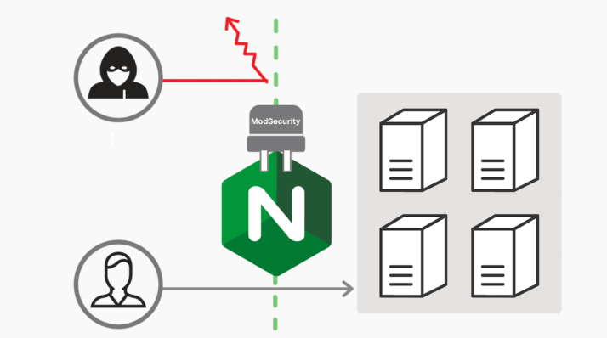

Figure ModSecurity integrated with Nginx

## Features, Functionalities, and Capabilities:

ModSecurity is renowned for its robust set of features and capabilities that significantly enhance the security of web applications:

* Real-time Monitoring and Logging: ModSecurity provides detailed logging capabilities, allowing for real-time monitoring of web traffic and capturing comprehensive data on each request and response. This aids in the identification and analysis of suspicious activities.
* Request and Response Filtering: With its powerful rule engine, ModSecurity can filter both inbound and outbound traffic based on a wide range of criteria. This includes blocking requests that match predefined patterns of known attacks, such as SQL injection and cross-site scripting (XSS).
* Anomaly Scoring: ModSecurity employs anomaly scoring to detect and block suspicious requests. Each request is assigned a score based on its behavior, and if the score exceeds a certain threshold, the request is blocked.
* Integration with OWASP Core Rule Set (CRS): The OWASP CRS is a set of generic attack detection rules designed to protect web applications from a broad range of vulnerabilities. When used with ModSecurity, these rules provide a robust defense against the most critical security risks identified by the OWASP Top Ten.
* Flexibility and Customization: ModSecurity allows administrators to define custom rules tailored to their specific security needs. This flexibility ensures that the WAF can adapt to unique threat landscapes and application requirements.

## Why ModSecurity?

The decision to integrate ModSecurity with Nginx was driven by several compelling factors:

* Open Source and Community Support: ModSecurity is an open-source solution with a large, active community of developers and security professionals. This ensures continuous improvement, regular updates, and a wealth of resources for troubleshooting and optimization.
* Compatibility and Performance: Nginx is a high-performance web server known for its scalability and efficiency. Integrating ModSecurity with Nginx leverages the strengths of both platforms, resulting in a solution that is both powerful and efficient in handling high volumes of traffic.
* Comprehensive Protection with OWASP CRS: The inclusion of the OWASP Core Rule Set enhances ModSecurity's ability to detect and block a wide range of attacks. This ensures that the solution provides comprehensive protection against the most common and critical web application vulnerabilities.

below is an illustrative diagram depicting the integration of ModSecurity with Nginx in the security architecture:

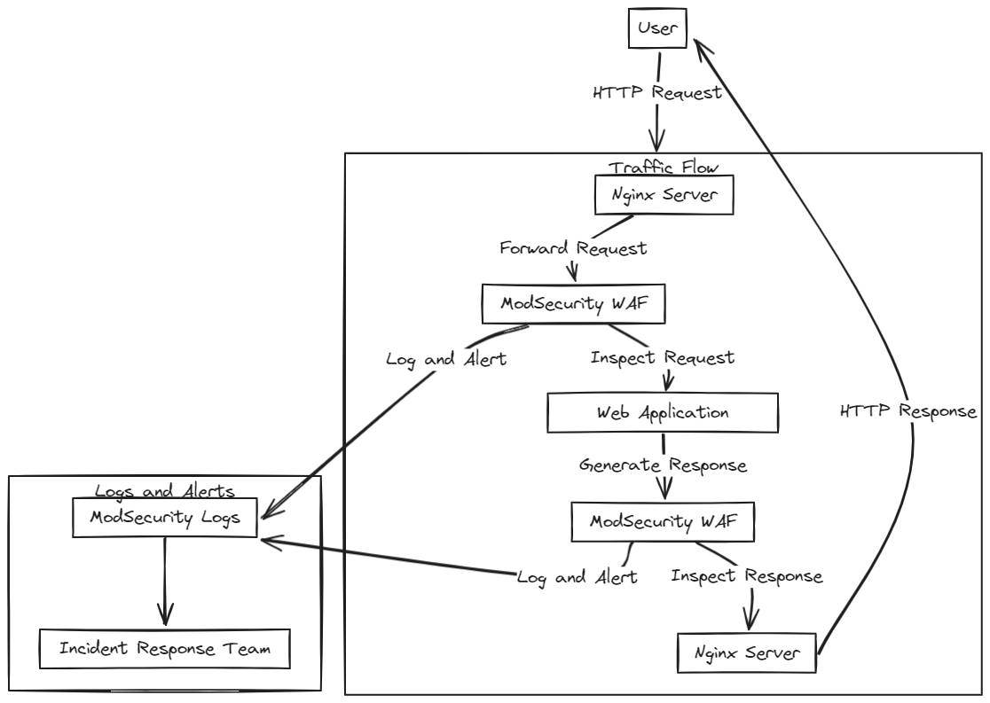

Figure Nginx with ModSecurity workflow

# 3.Attack Scenarios on Security Solutions

## SQL injection attack

### Methodology:

SQL Injection (SQLi) involves injecting malicious SQL code into a query to manipulate the database. This can lead to unauthorized data access, data modification, or even complete database compromise.

### Impact:

Successful SQLi attacks can expose sensitive information, disrupt operations, and lead to significant financial and reputational damage.

### Launch Method:

To demonstrate SQLi, we used a vulnerable web application and injected SQL commands into input fields. For instance, entering ' or 1=1-- into a login field bypasses authentication.

### Evidence:

As shown below

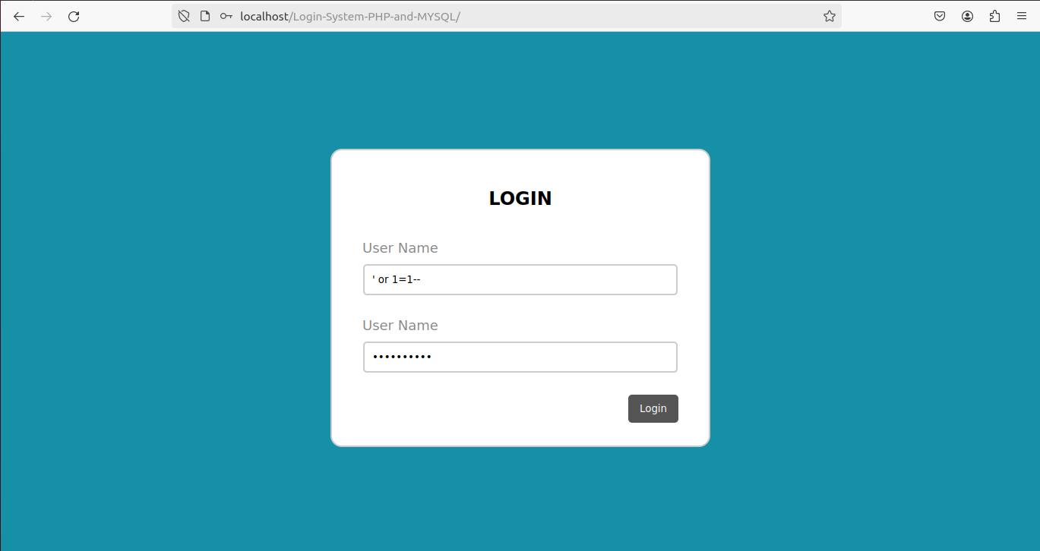

Figure SQLi attack

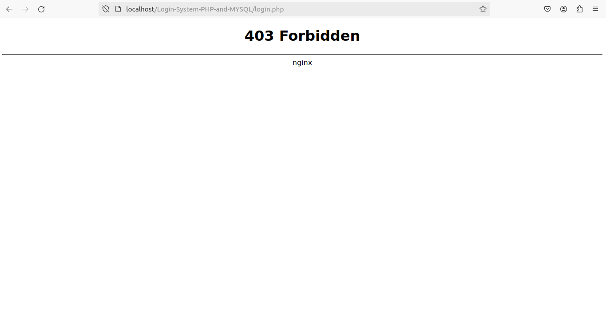

Figure WAF response to SQL injection attack

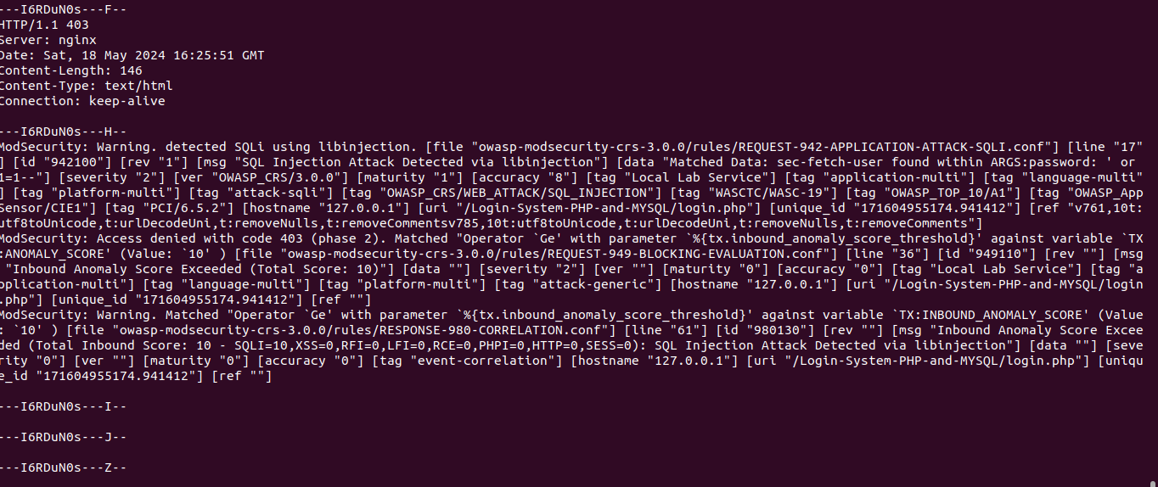

Figure SQL Injection logs

## URL SQL Injection

### Methodology:

URL SQL Injection involves appending malicious SQL code to URL parameters. This type of attack targets applications that incorporate user input directly into SQL queries without proper sanitization.

### Impact:

Similar to traditional SQLi, URL SQL Injection can result in unauthorized data access and database manipulation.

### Launch Method:

I crafted URLs with SQL injection payloads, such as http://example.com/items?id=1 OR 1=1.

### Evidence:

As shown below

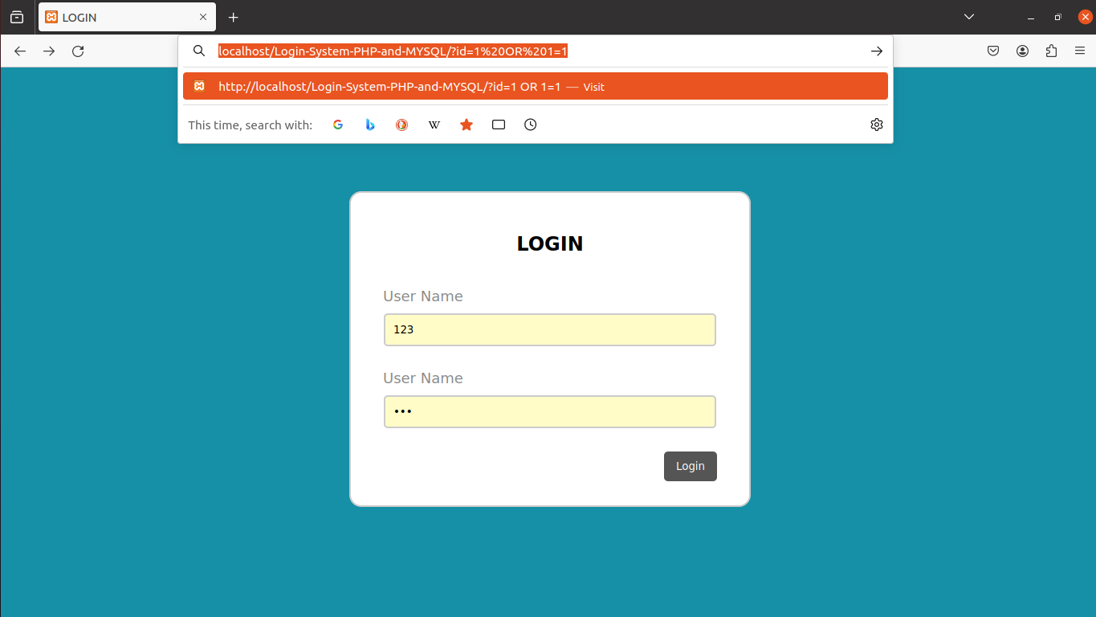

Figure SQL injection attack 2

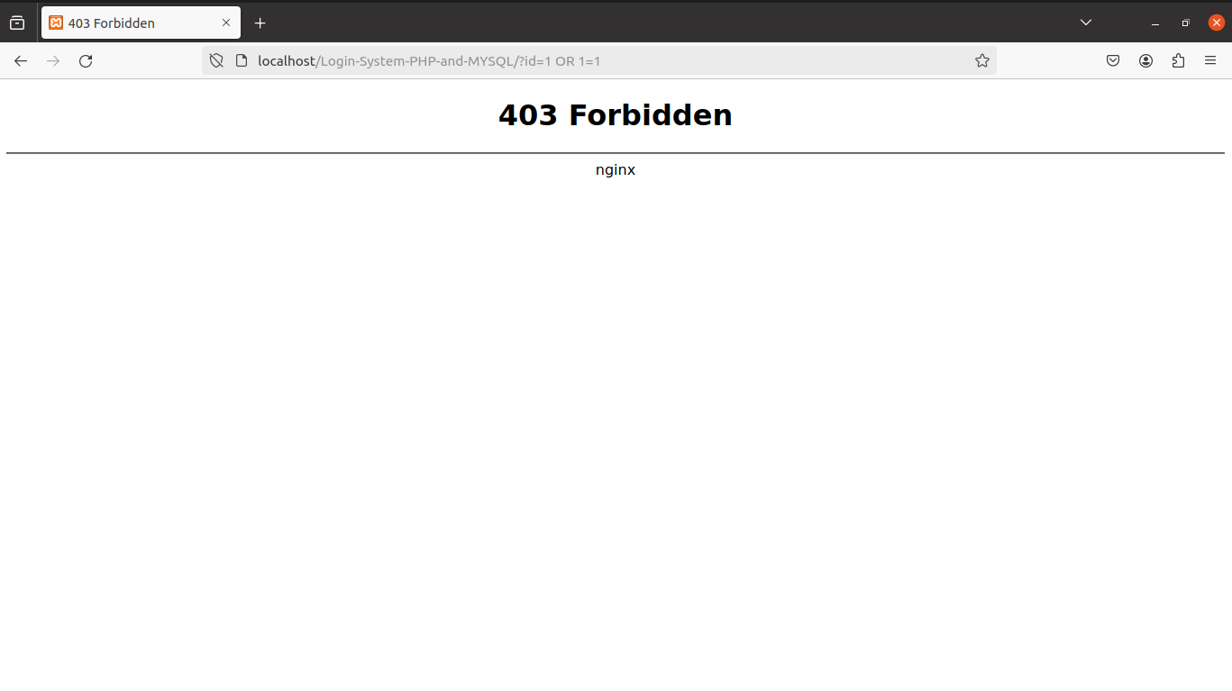

Figure WAF response to URL SQL injection

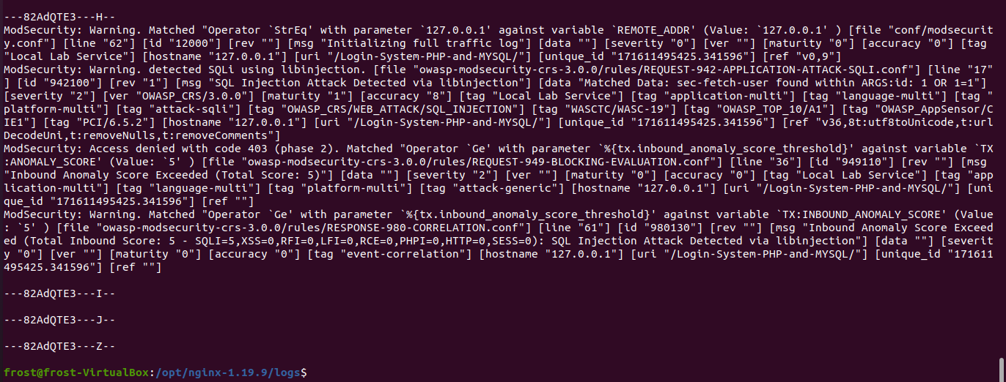

Figure SQLi through url logs

## XXS attack

### Methodology:

XSS attacks inject malicious scripts into web pages viewed by other users. These scripts can steal cookies, session tokens, or perform actions on behalf of the user.

### Impact:

XSS can lead to session hijacking, data theft, and unauthorized actions on behalf of users.

### Launch Method:

I embedded JavaScript payloads into input fields, such as <script>alert('XSS');</script>.

### Evidence:

As shown below

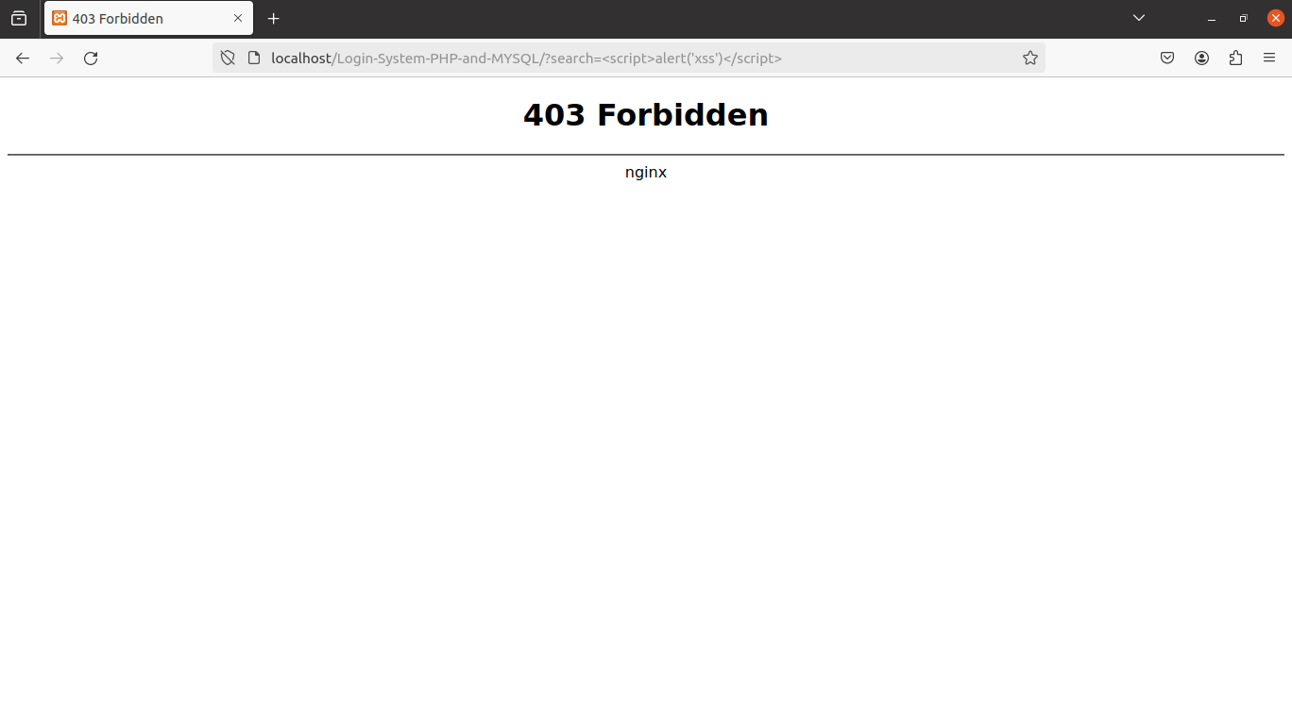

Figure WAF response to XSS attack

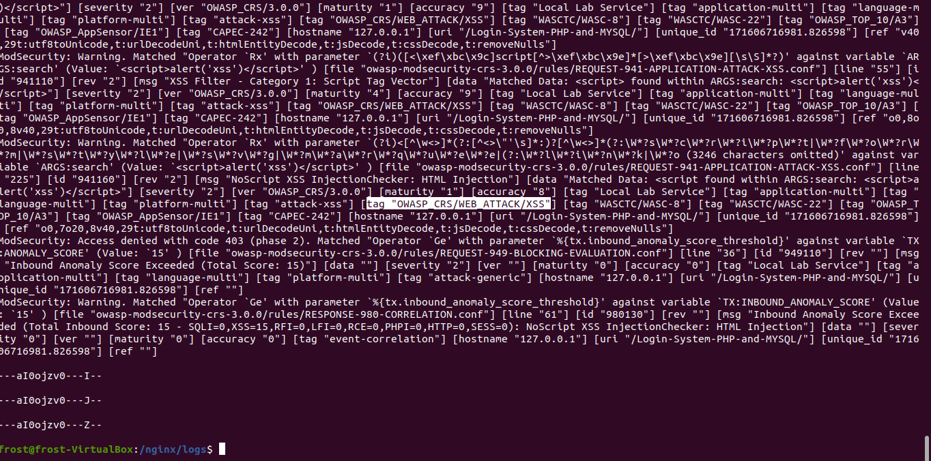

Figure XSS logs

## Whitelist and Blacklist Mechanisms

### Methodology:

Whitelist and blacklist mechanisms are used to control access to resources based on predefined rules. Whitelists allow only specific entities, while blacklists block known malicious entities.

### Impact:

Properly implemented whitelists and blacklists can significantly enhance security by restricting access to trusted entities and blocking malicious ones.

### Launch Method:

To test these mechanisms, I attempted to access restricted resources using both allowed and disallowed inputs.

### Evidence:

As shown in blacklist rule and in

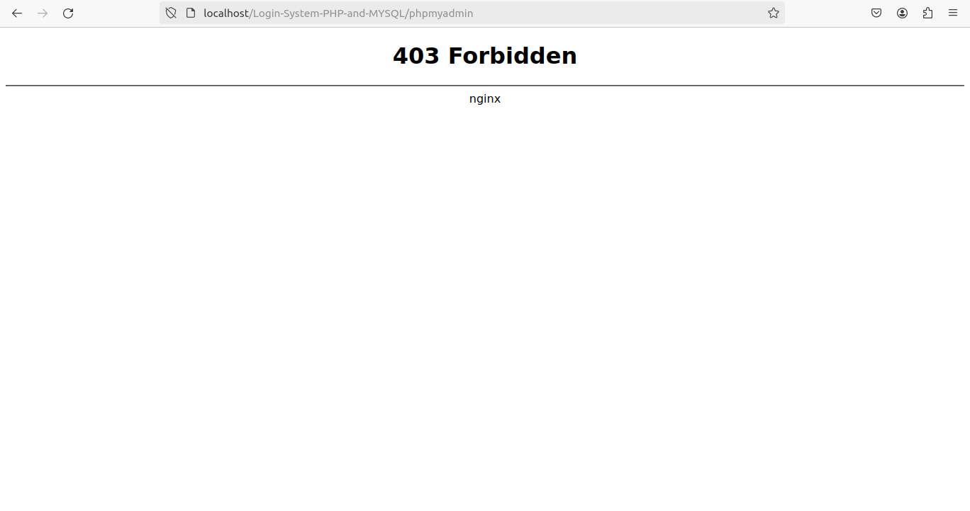

Figure blacklist rule

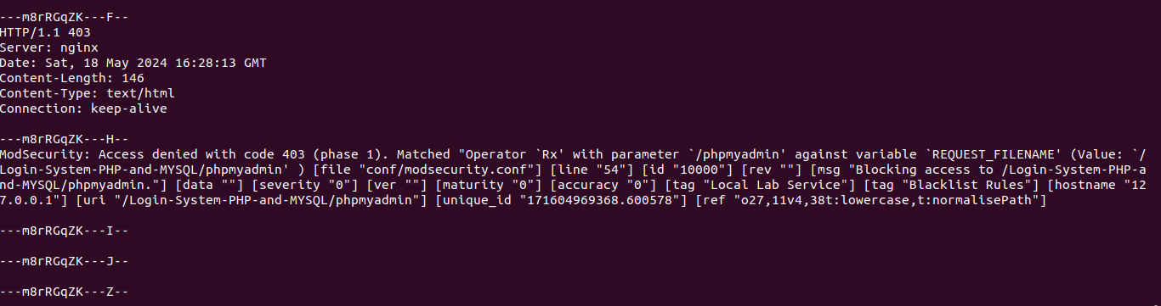

Figure blacklist logs

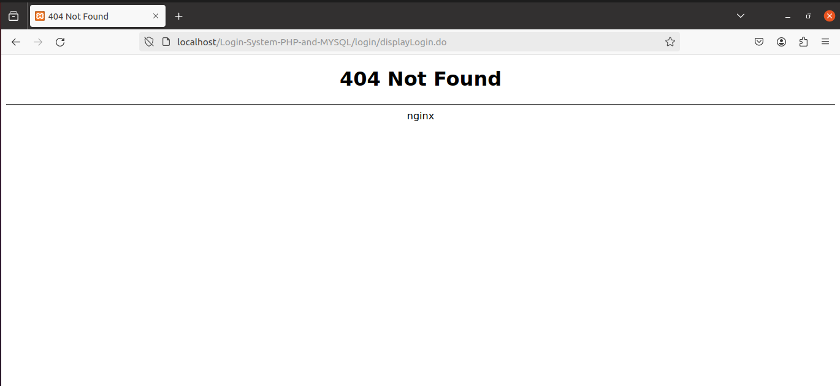

Figure whitelist rule

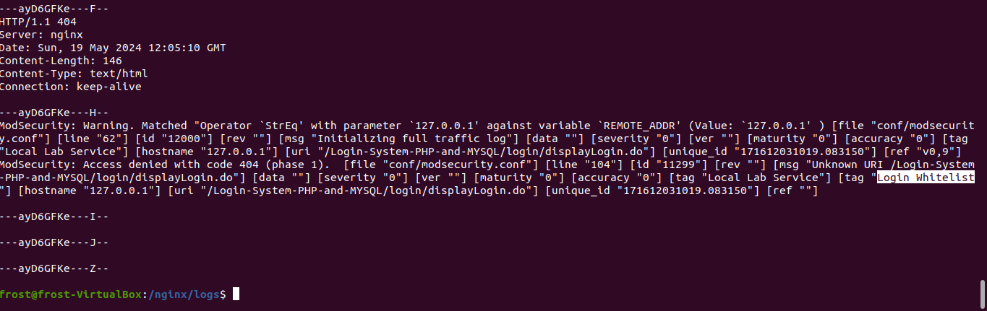

Figure whitelist logs

# 4.Results of the Scenarios

## Introduction

This section provides a detailed analysis of how our security solution, comprising Nginx with ModSecurity and the OWASP Core Rule Set (CRS), performed against the selected attack scenarios. It identifies any vulnerabilities or weaknesses observed during testing, discusses the effectiveness of the solution in mitigating the attacks, and presents quantitative metrics to support the analysis.

## 1. SQL Injection

### Performance Analysis:

ModSecurity, with the OWASP CRS, effectively detected and blocked SQL injection attempts. The predefined rules in the CRS identified malicious patterns in input fields and URL parameters, preventing unauthorized database access.

### Effectiveness:

The solution was highly effective in mitigating SQL injection attacks, ensuring database integrity and preventing data leakage.

### Metrics:

See the logs above

## 2. URL SQL Injection

### Performance Analysis:

URL SQL injection attempts were also effectively intercepted and blocked by ModSecurity with the OWASP CRS. The rules efficiently parsed and sanitized URL parameters to neutralize malicious payloads.

### Effectiveness:

The solution demonstrated robust protection against URL SQL injection attacks, maintaining secure access controls and data protection.

### Metrics:

See the logs above

## 3. Cross-Site Scripting (XSS)

### Performance Analysis:

The security solution effectively blocked XSS attempts by filtering out malicious scripts from user input fields. The CRS includes comprehensive XSS protection rules that prevent the execution of harmful scripts.

### Effectiveness:

The solution was effective in mitigating XSS attacks, protecting user sessions and preventing unauthorized actions.

### Metrics:

See the logs above

## 4. Whitelist and Blacklist Mechanisms

### Performance Analysis:

Whitelist and blacklist mechanisms were tested by attempting to access restricted resources with both allowed and disallowed inputs. The security solution correctly allowed or blocked access based on the predefined rules.

### Effectiveness:

The solution effectively enforced access control policies, enhancing overall security by restricting access to trusted entities and blocking known malicious ones.

### Metrics:

See the logs blacklist logs and whitelist logs

# 5.Conclusion

## Summary of Key Findings and Observations

The report investigated the integration of ModSecurity, a robust Web Application Firewall (WAF), with the Nginx server to enhance cybersecurity measures for web applications. The key findings indicate that ModSecurity, coupled with the OWASP Core Rule Set (CRS), effectively mitigates common web-based attacks such as SQL injection (SQLi) and cross-site scripting (XSS). The testing of various attack scenarios, including URL SQL injection and whitelist/blacklist mechanisms, demonstrated the solution's robustness in detecting and blocking malicious traffic.

## Evaluation of the Effectiveness and Efficiency of the Chosen Defense Security Solution

The chosen security solution, comprising Nginx with ModSecurity and the OWASP CRS, performed exceptionally well against the selected attack scenarios. It efficiently detected and blocked SQL injection and XSS attacks, maintaining database integrity and protecting user sessions. The whitelist and blacklist mechanisms accurately controlled access based on predefined rules, further enhancing security. The comprehensive logging features provided valuable insights into suspicious activities, aiding in proactive threat management.

## Overall Assessment of the Project's Success in Achieving Its Objectives

The project's primary objective of evaluating the effectiveness of ModSecurity in mitigating common web-based attacks was successfully achieved. The integration of ModSecurity with Nginx provided a powerful defense layer, significantly improving the security posture of web applications. However, some difficulties were encountered during the project, such as configuring ModSecurity to work seamlessly with Nginx and ensuring comprehensive logging features. Some minor issues, such as optimizing performance under high traffic loads, remain and require further attention.

## Recommendations for Further Enhancements or Areas of Improvement

* Performance Optimization: Further optimization is needed to handle high volumes of traffic efficiently. This includes fine-tuning ModSecurity rules and enhancing server performance.
* Continuous Monitoring: Implement continuous security monitoring to promptly detect and respond to emerging threats.
* Rule Customization: Develop and implement custom rules tailored to specific security needs, ensuring adaptability to unique threat landscapes.
* Regular Updates: Ensure ModSecurity and OWASP CRS are regularly updated to incorporate the latest security patches and improvements.
* User Training: Conduct regular training sessions for administrators and users to stay informed about the latest security practices and threat trends.

# References

## Netnea's Nginx Tutorials:

* Tutorial 1: "Compiling Nginx," [Online]. Available: <https://www.netnea.com/cms/nginx-tutorial-1_compiling-nginx/>
* Tutorial 2: "Minimal Nginx Configuration," [Online]. Available: <https://www.netnea.com/cms/nginx-tutorial-2_minimal-nginx-configuration/>
* Tutorial 6: "Embedding ModSecurity," [Online]. Available: <https://www.netnea.com/cms/nginx-tutorial-6_embedding-modsecurity/>

## OWASP ModSecurity Core Rule Set:

* OWASP Foundation, "OWASP ModSecurity Core Rule Set," [Online]. Available: <https://coreruleset.org/docs/deployment/engine_integration_options/>

## Medium Article on Nginx:

* Dissanayake, Oct 20, 2021, "What is Nginx?", Medium. Available: <https://medium.com/geekculture/what-is-nginx-2edfdad3722b>

## Namecheap Knowledgebase Article on ModSecurity:

* Namecheap Support, "What is ModSecurity and Why Do We Need It?," Namecheap Knowledgebase. Available: <https://www.namecheap.com/support/knowledgebase/article.aspx/9542/22/what-is-modsecurity-and-why-do-we-need-it/>

## Wikipedia Page on ModSecurity:

* Wikipedia contributors. (Year, Month Day). "ModSecurity," Wikipedia, The Free Encyclopedia. Available: <https://en.wikipedia.org/wiki/ModSecurity>

## OWASP ModSecurity GitHub Repository:

* OWASP ModSecurity, "ModSecurity GitHub Repository," [Online]. Available: <https://github.com/owasp-modsecurity/ModSecurity>

## Nginx Official Download Page:

* Nginx, "Download Nginx," [Online]. Available: <http://nginx.org/download>

# Appendix

## Compiling NGINX

### Step 1: Preparing the directory tree for the source code



### Step 2: Meeting the requirements for NGINX

Install these packages:

* build-essential
* binutils
* gcc
* libpcre3-dev
* libssl-dev
* zlib1g-devS

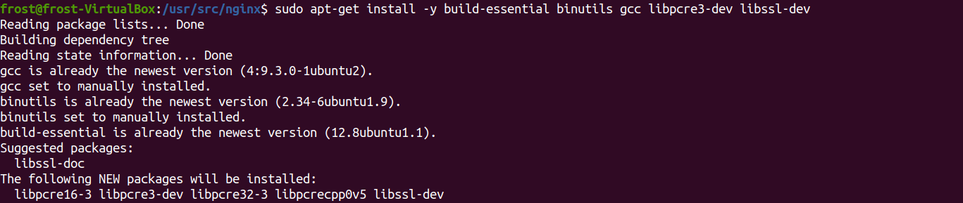

### Step 3: Downloading the source code and verifying the integrity of the code

Download the code of nginx along with its key to insure the integrity of the code

check the signature on the code based on a publicly available key of one of the lead developers.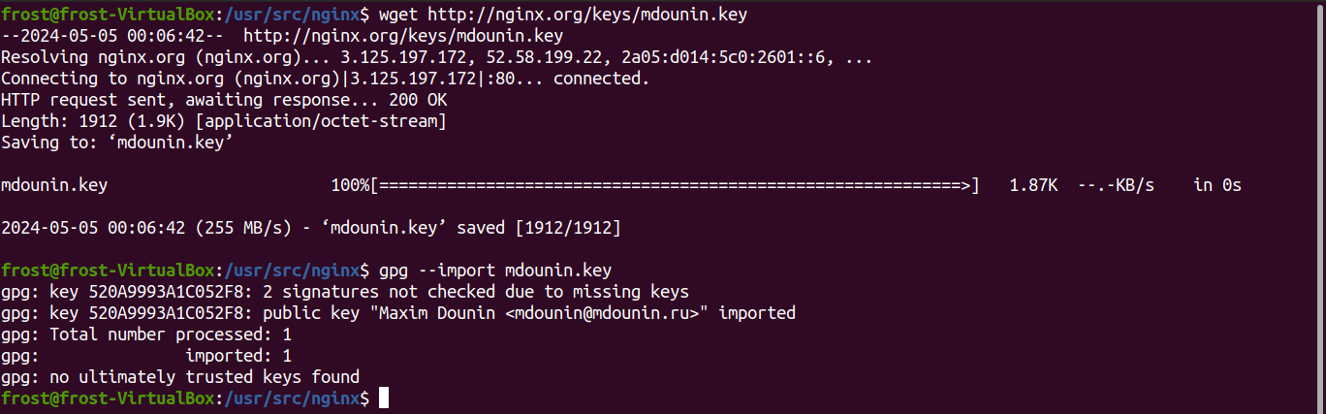

The long id is: 520A9993A1C052F8, let’s check the signature

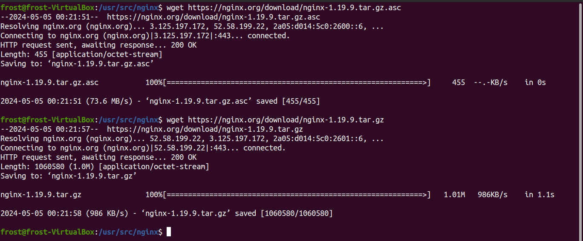

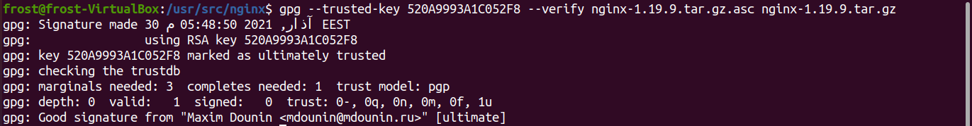

Signature is checked successfully using the key

### Step 4: Unpacking and configuring the compiler

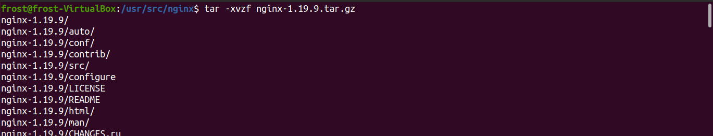

configure compiler, install it on custom directory,

--prefix=/opt/nginx-1.19.9: directory where to install compiler, ***to keep our work on single branch***

--with-http_ssl_module: This option enables the SSL (Secure Sockets Layer) module in Nginx, allowing the server to support HTTPS connections.

--with-threads: Enabling threads support allows Nginx to handle multiple connections concurrently using threads. To deal with a large number of simultaneous requests.

--with-file-aio: This option enables asynchronous I/O (Input/Output) operations for file handling in Nginx. Asynchronous I/O allows Nginx to perform file operations without blocking the main process, which can enhance performance and scalability.

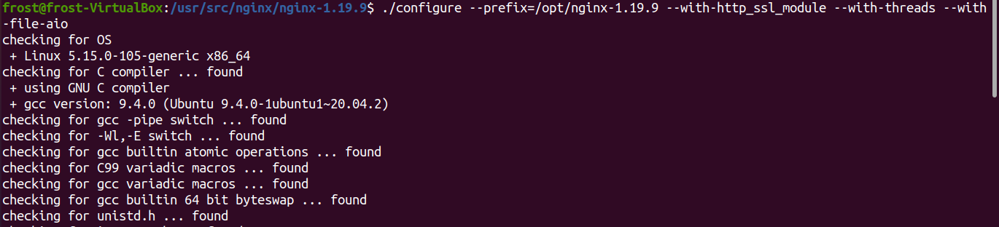

We get the following error simply fix that by

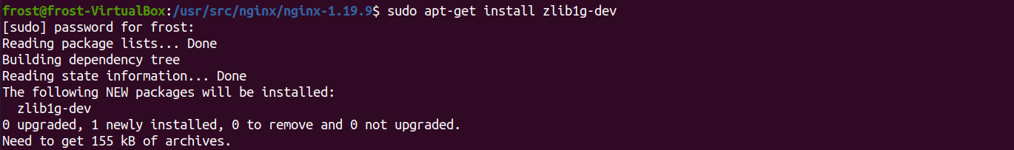

Rerun “./configure --prefix=/opt/nginx-1.13.9 --with-http_ssl_module --with-threads --with-file-aio”

If you get the following output then you’re in mint condition

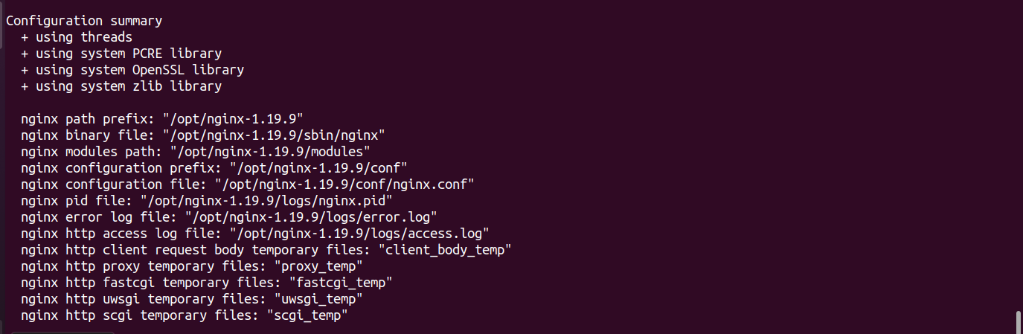

### Step 5: Compile the nginx server

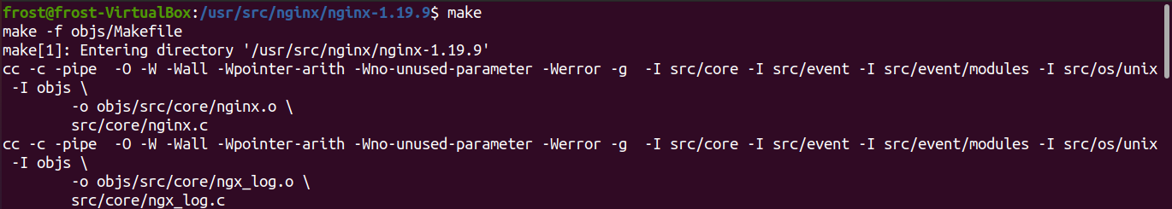

**Note: this may take some time**

### Step 6: Installing

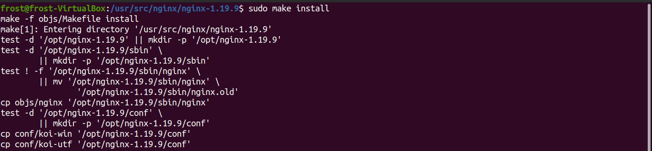

Since working with configuration files is sensitive, we change the owner of /opt/nginx-1.19.9 and everything inside it to the user who executes the command with root



To ensure dynamicity of the work and to try different versions, modules, and patches. we make it easy by creating a soft link from /nginx to the current NGINX web server , now we can run nginx server from one place



### Step 7: Starting nginx

Starting nginx server is a super user accessibility

Let’s try to start nginx server

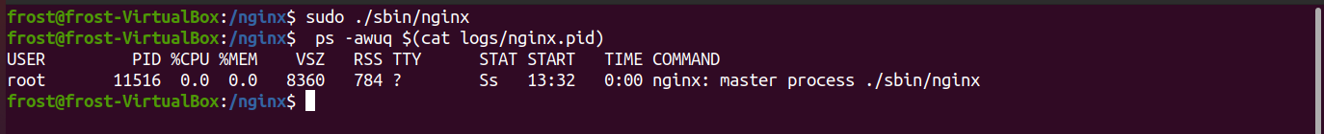

Check for details about the running nginx server

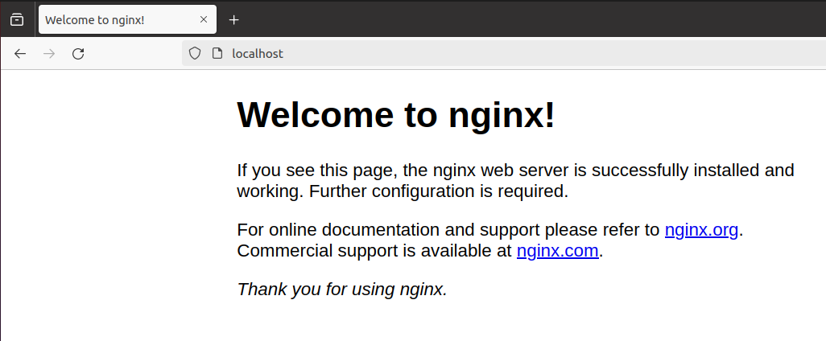

Our nginx server is running like a well-oiled machine

Now stop the server



### Step 8: Inspecting the server’s binary and related libraries

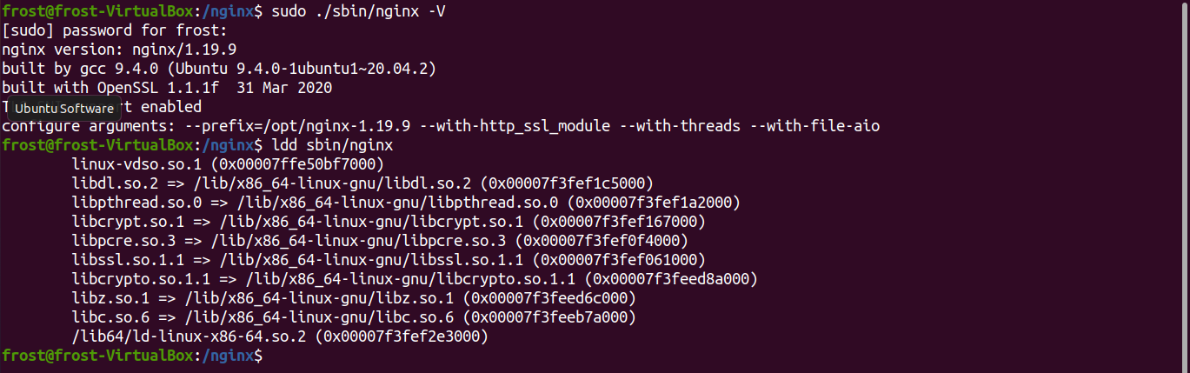

## NGINX Configuration

### Step 1: Creating a minimal configuration

Modify the nginx.conf file, and replace the default configuration with the following configuration

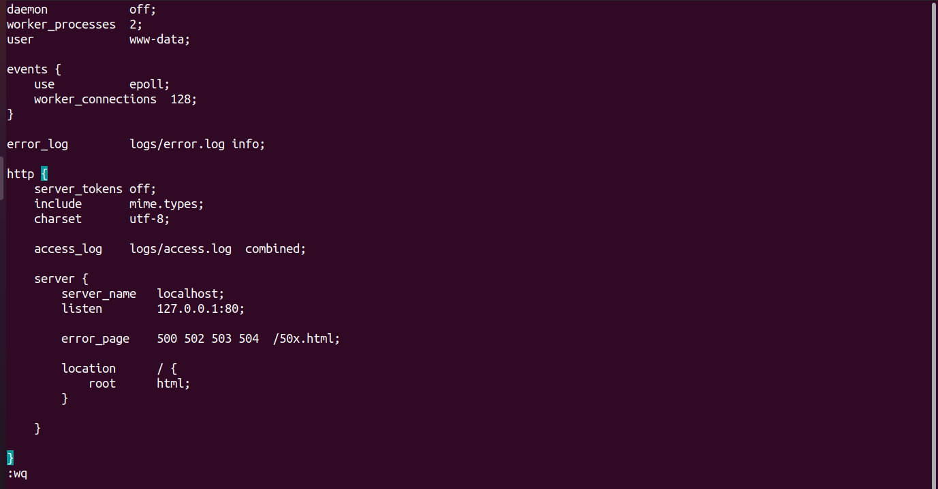

### Step 2: Starting and testing the server

Once our configuration is ready, we start the nginx server for testing

**NOTE: the server started in the foreground and not as a daemon**



Take a look



Communicate with the server using curl

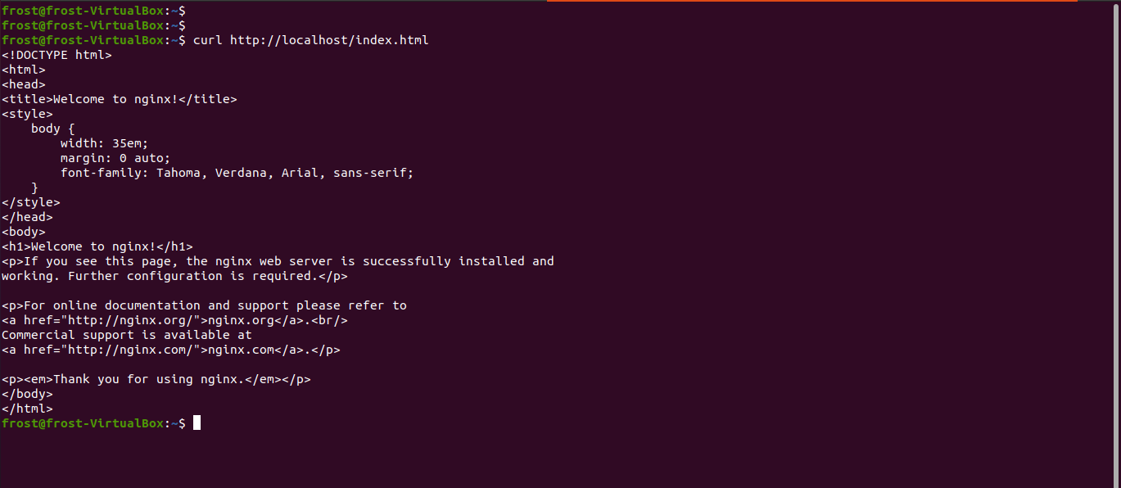

The server responded to our request

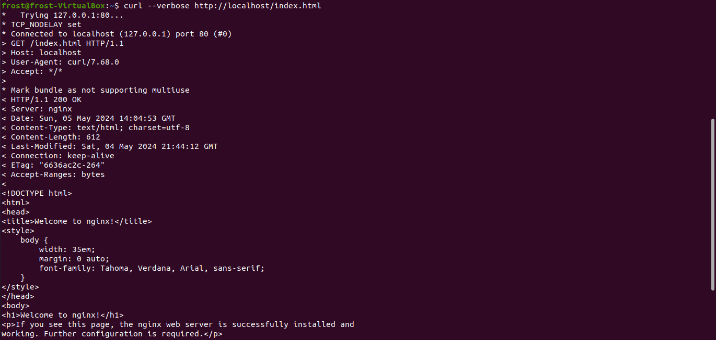

To check simple benchmark for the server performance

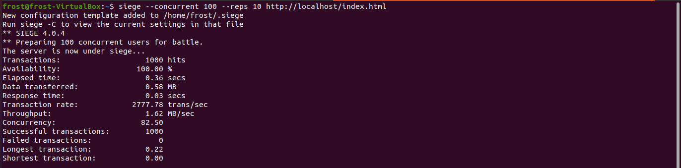

The siege command was executed with a concurrency level of 100 users making 10 repetitions of requests. The output shows that 1000 hits were made successfully, indicating an availability of 100%. The total elapsed time for these transactions was 0.36 seconds, during which 0.58 MB of data was transferred. The response time was very low at 0.03 seconds, showcasing efficient server performance under load. The transaction rate was 2777.78 transactions per second, with a throughput of 1.62 MB per second. The concurrency level during this test reached 82.50, demonstrating the system's ability to handle multiple concurrent requests. Importantly, there were no failed transactions, indicating a stable and robust server response. The longest transaction took 0.22 seconds, while the shortest was instantaneous at 0.00 seconds, reflecting consistent and fast response times across the board.

## Embedding ModSecurity

### Step 1: Downloading the source code and verifying the checksum

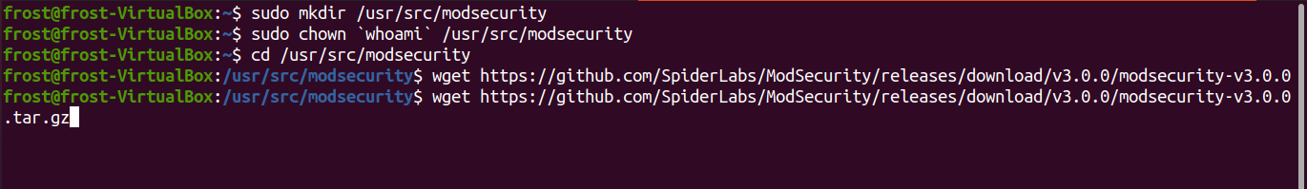

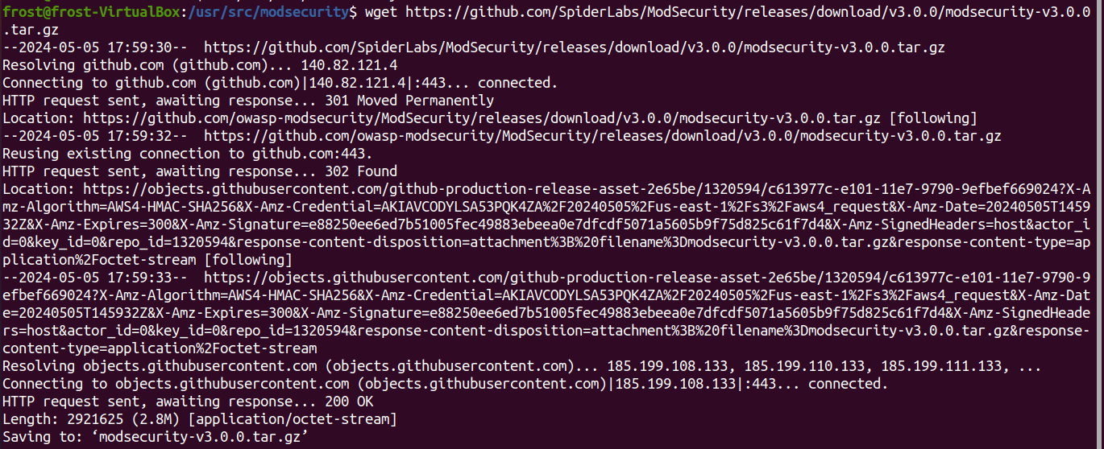

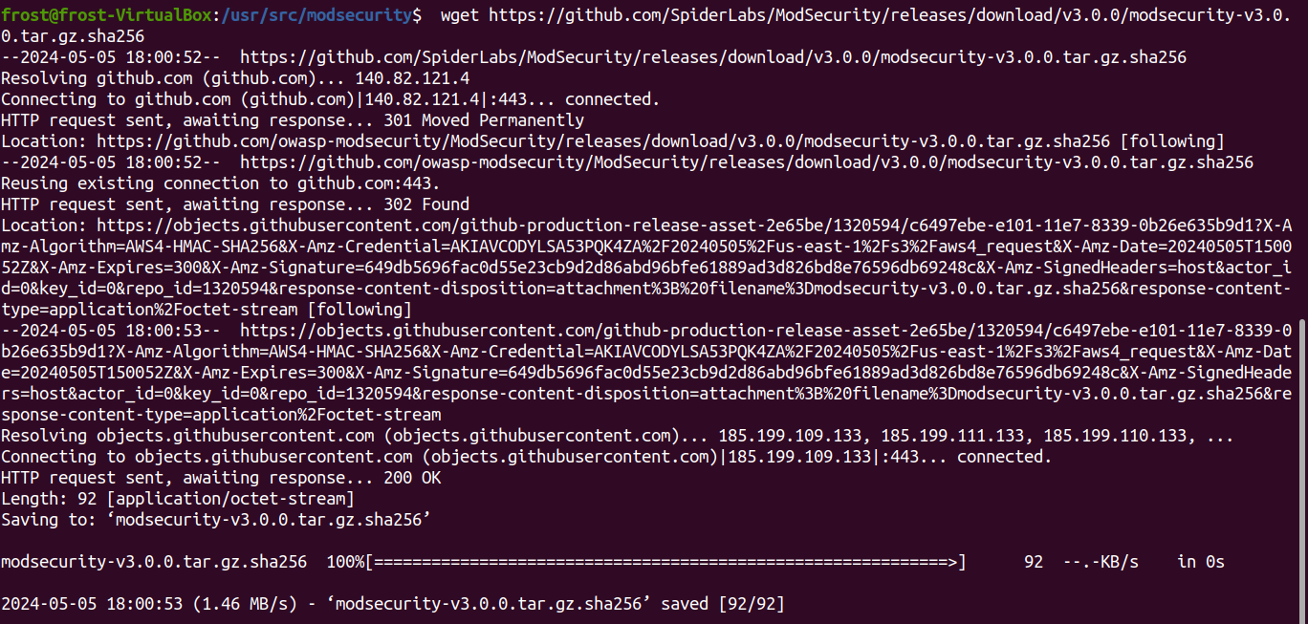



### Step 2: Unpacking and configuring the compiler

Insure the following packages are installed

* libxml2
* libxml2-dev
* libexpat1-dev
* libpcre3-dev
* libpcre++-dev
* libyajl-dev
* libgeoip-dev
* libcurl4-gnutls-dev
* dh-autoreconf

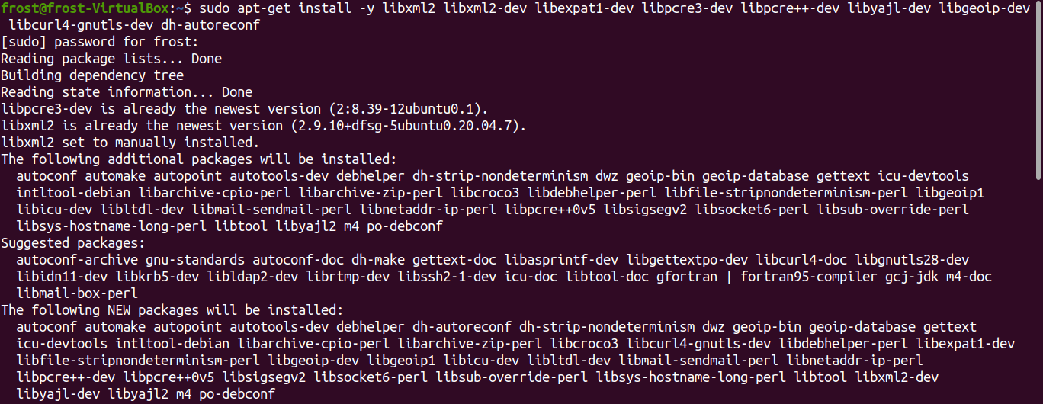

Unpack Modsecurity

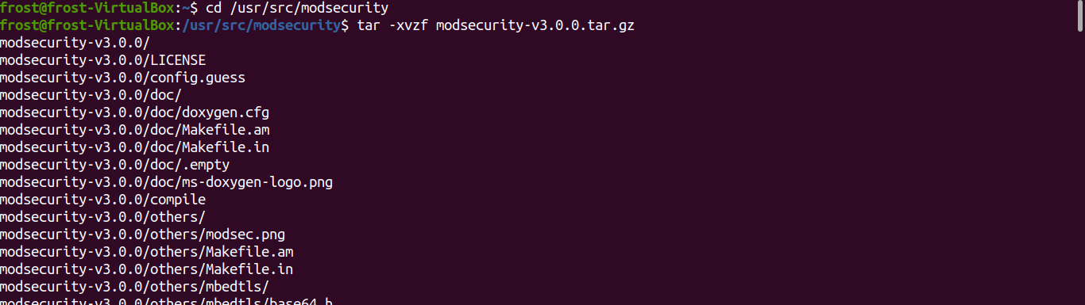

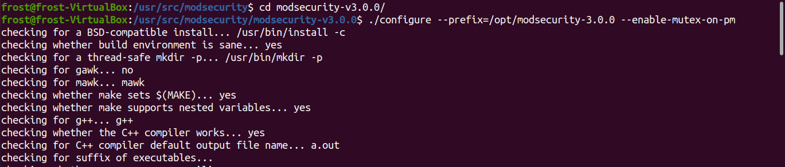

Everything is fine

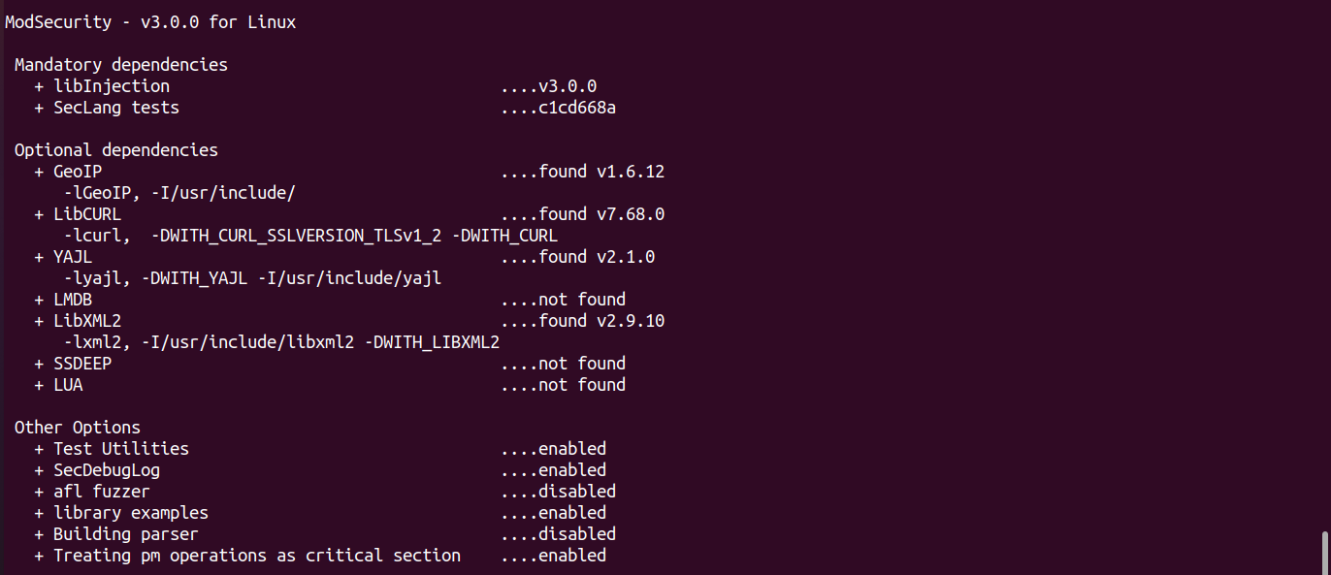

### Step 3: Compiling and installing standalone ModSecurity

**Note: This will take some time**

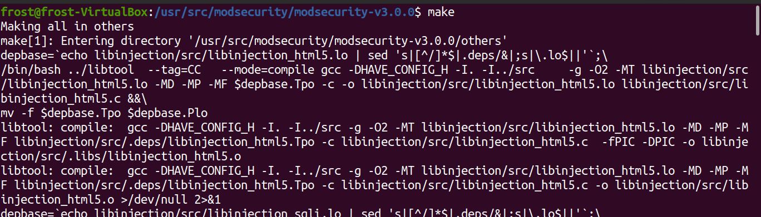

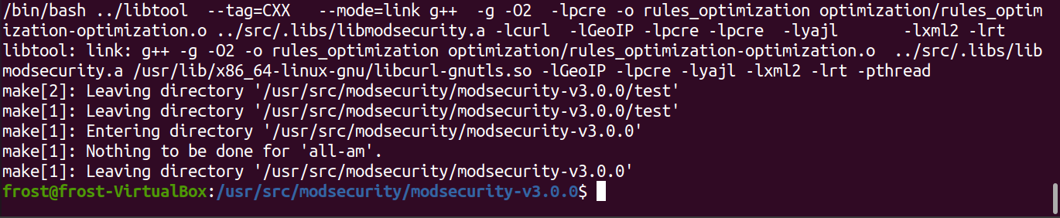

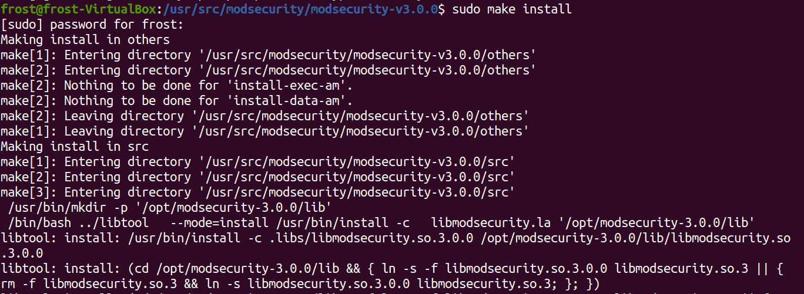

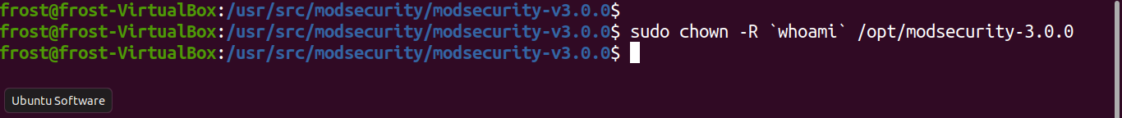

### Step 4: Compiling the connector module

ModSecurity 3.0 runs standalone. It is integrated via a NGINX module that organizes the exchange between the webserver and ModSecurity. This allows ModSecurity remain webserver agnostic while the whole integration happens in the connector module.

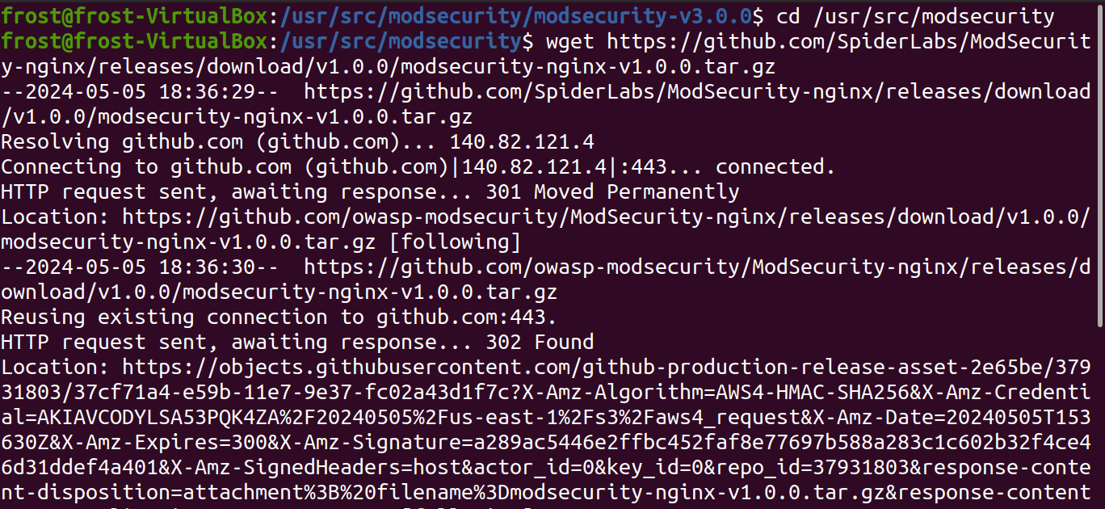

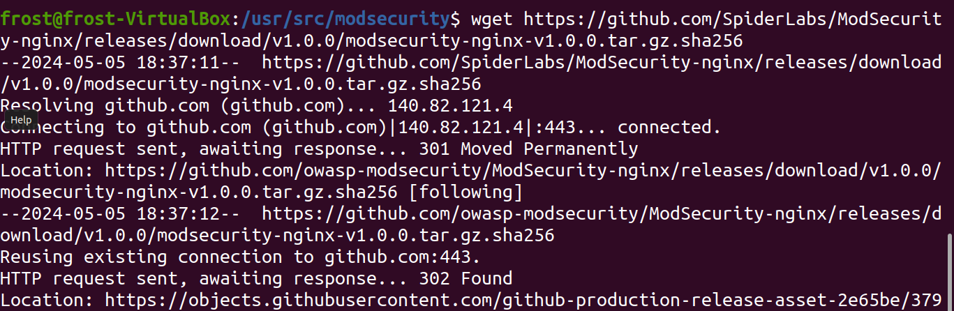



Unpack the connector

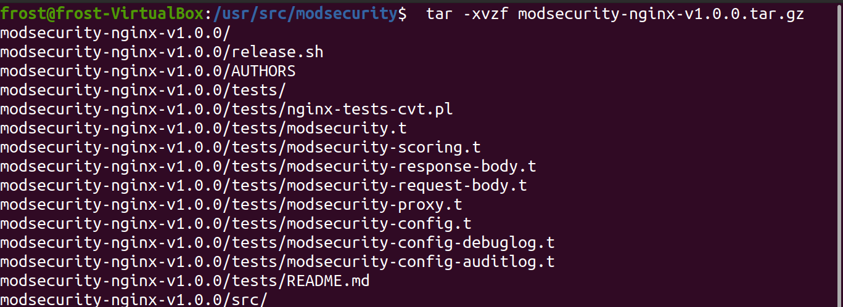

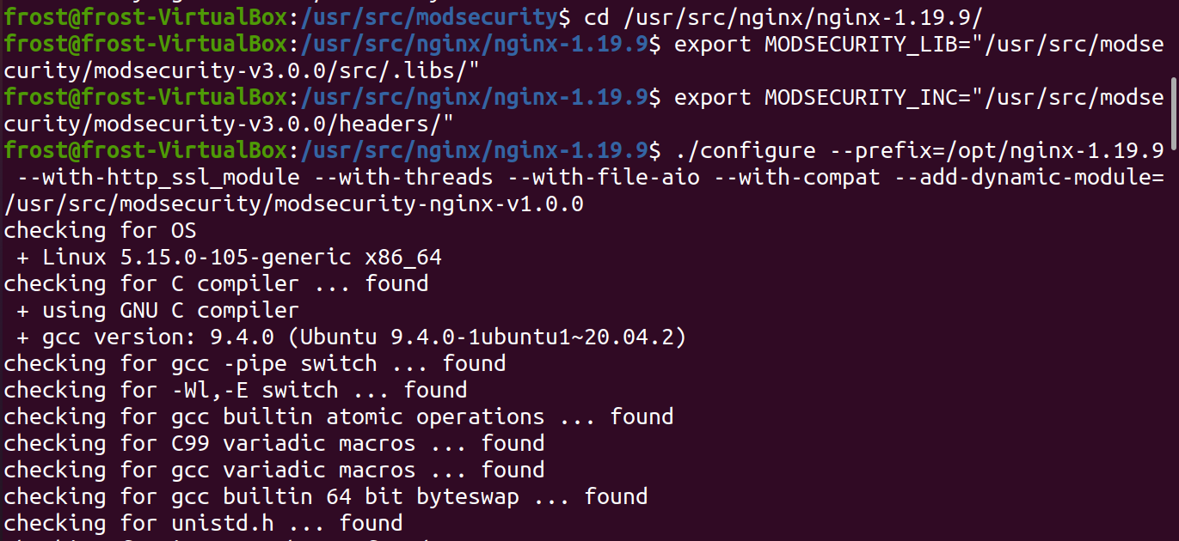

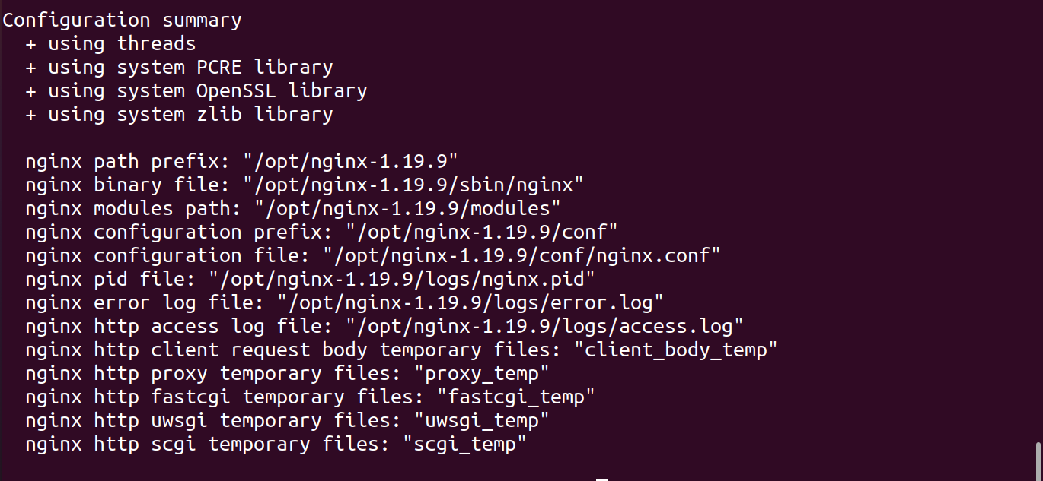

We need to build nginx server again

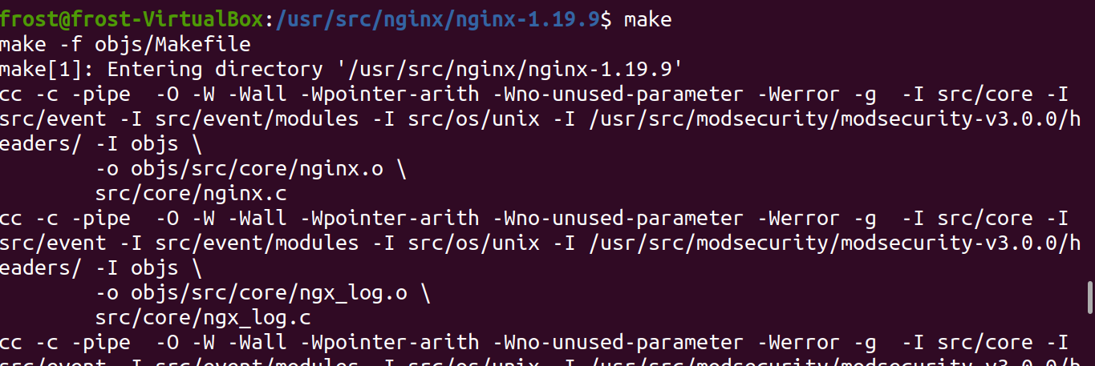

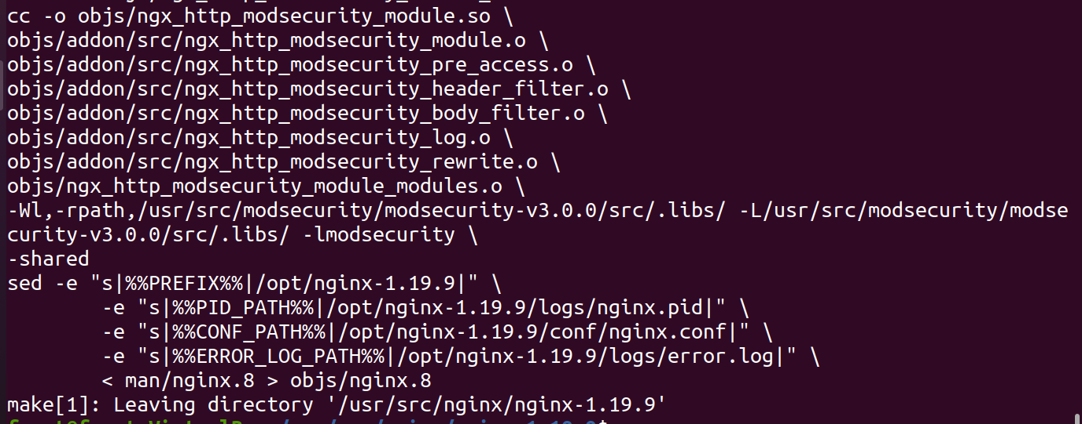

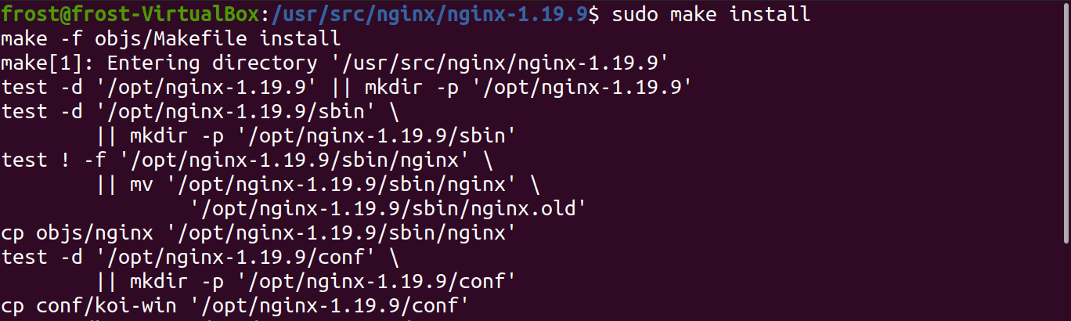

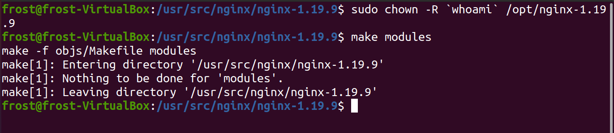copy module to Nginx destination

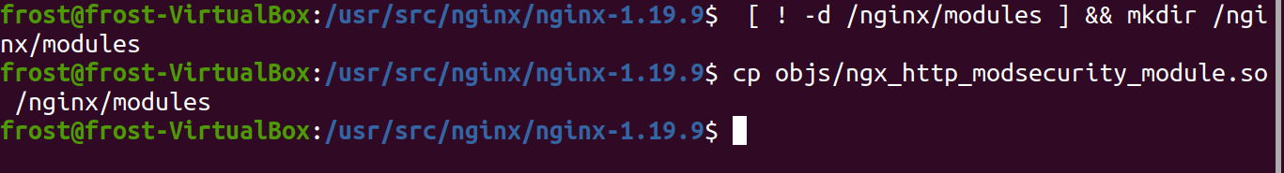

### Step 5: Creating the base configuration

First we need to add the load_module statement in the top level of the configuration.



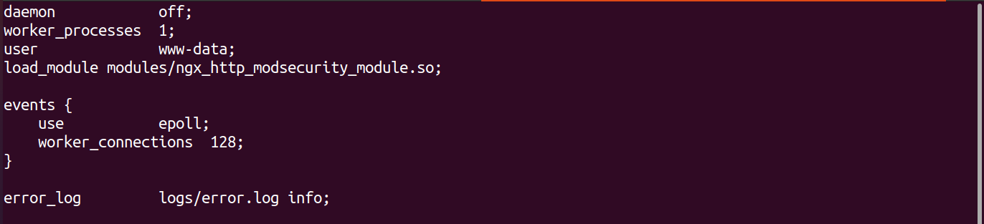

enable ModSecurity and do the baseline configuration within http block.

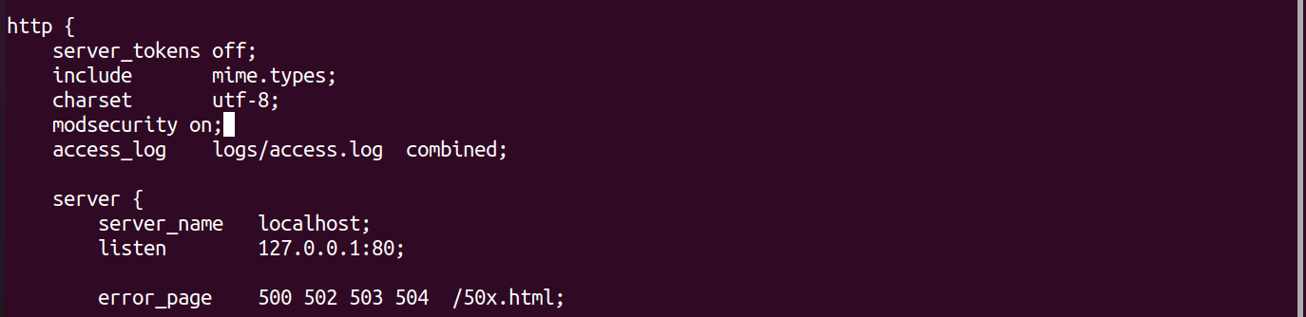

Create configuration file for modsecurity in “/opt/nginx-1.19.9/conf” directory

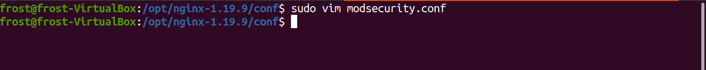

Paste the following configuration:

SecRuleEngine On

SecRequestBodyAccess On

SecRequestBodyLimit 13107200

SecRequestBodyNoFilesLimit 64000

SecResponseBodyAccess On

SecResponseBodyLimit 10000000

SecTmpDir /tmp/

SecDataDir /tmp/

SecUploadDir /tmp/

SecAuditEngine RelevantOnly

SecAuditLogRelevantStatus "^(?:5|4(?!04))"

SecAuditLogParts ABEFHIJZ

SecAuditLogType Serial

SecAuditLog logs/modsec_audit.log

SecAuditLogStorageDir logs/audit

SecPcreMatchLimit 500000

SecPcreMatchLimitRecursion 500000

SecDebugLog logs/modsec_debug.log

SecDebugLogLevel 0

SecDefaultAction "phase:1,pass,log,tag:'Local Lab Service'"

SecDefaultAction "phase:2,pass,log,tag:'Local Lab Service'"

# == ModSec Rule ID Namespace Definition

# Service-specific before Core-Rules: 10000 - 49999

# Service-specific after Core-Rules: 50000 - 79999

# Locally shared rules: 80000 - 99999

# Recommended ModSec Rules (few): 200000 - 200010

# OWASP Core-Rules: 900000 – 999999

# === ModSec Recommended Rules (in modsec src package) (ids: 200000-200010)

SecRule REQUEST_HEADERS:Content-Type "(?:application(?:/soap\+|/)|text/)xml" \

"id:200000,phase:1,t:none,t:lowercase,pass,nolog,ctl:requestBodyProcessor=XML"

SecRule REQUEST_HEADERS:Content-Type "application/json" \

"id:200001,phase:1,t:none,t:lowercase,pass,nolog,ctl:requestBodyProcessor=JSON"

SecRule REQBODY_ERROR "!@eq 0" \

"id:200002,phase:2,t:none,deny,status:400,log,\

msg:'Failed to parse request body.',logdata:'%{reqbody_error_msg}',severity:2"

SecRule MULTIPART_STRICT_ERROR "!@eq 0" \

"id:200003,phase:2,t:none,deny,status:403,log, \

msg:'Multipart request body failed strict validation: \

PE %{REQBODY_PROCESSOR_ERROR}, \

BQ %{MULTIPART_BOUNDARY_QUOTED}, \

BW %{MULTIPART_BOUNDARY_WHITESPACE}, \

DB %{MULTIPART_DATA_BEFORE}, \

DA %{MULTIPART_DATA_AFTER}, \

HF %{MULTIPART_HEADER_FOLDING}, \

LF %{MULTIPART_LF_LINE}, \

SM %{MULTIPART_MISSING_SEMICOLON}, \

IQ %{MULTIPART_INVALID_QUOTING}, \

IP %{MULTIPART_INVALID_PART}, \

IH %{MULTIPART_INVALID_HEADER_FOLDING}, \

FL %{MULTIPART_FILE_LIMIT_EXCEEDED}'"

SecRule TX:/^MSC_/ "!@streq 0" \

"id:200005,phase:2,t:none,deny,status:500,\

msg:'ModSecurity internal error flagged: %{MATCHED_VAR_NAME}'"

# === ModSecurity Rules

#

# ...

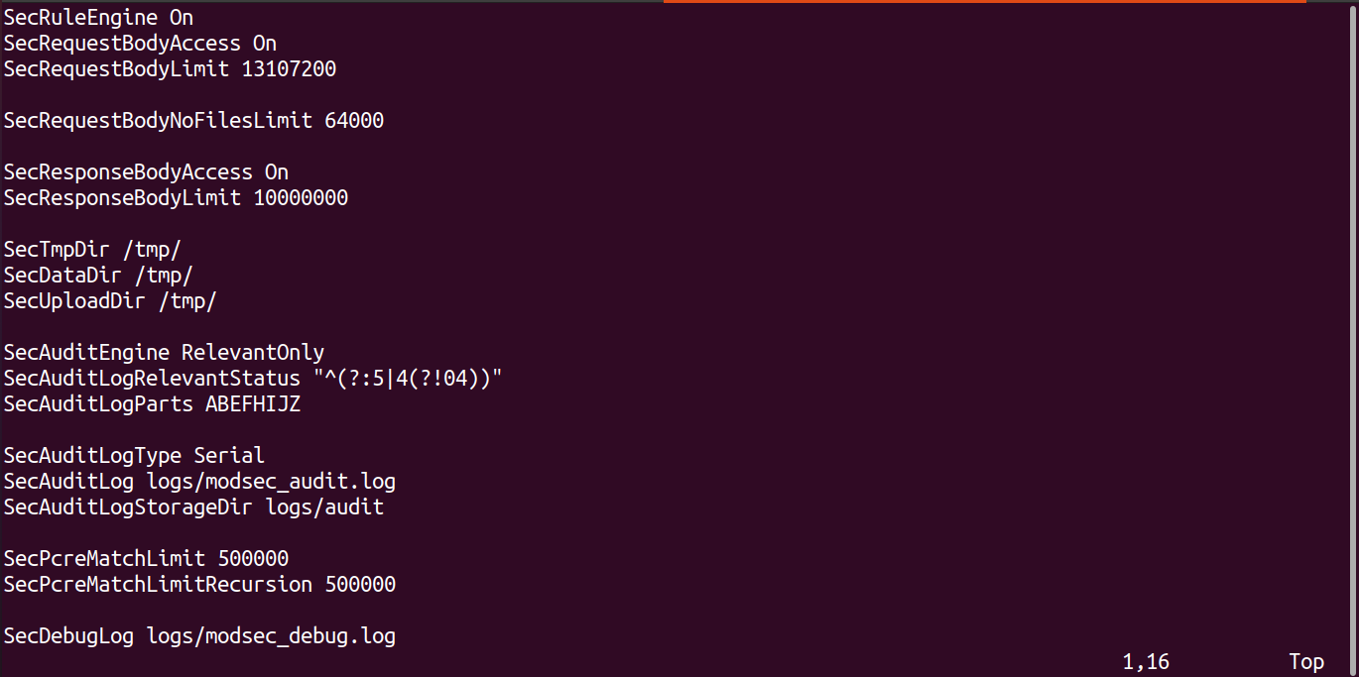

Figure ModSecurity configuration sample

Include modsecurity.conf file in nginx.conf

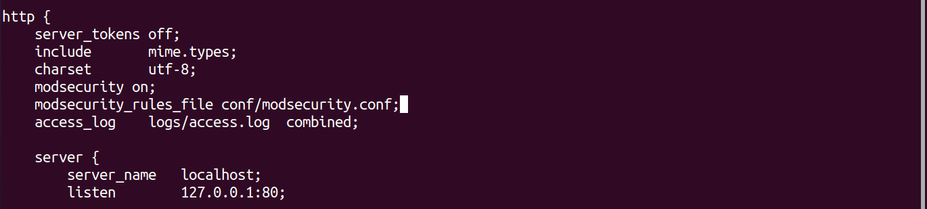

For auditing and logging configuration, let’s do the following



Add some extra rule for whitelist control

SecMarker BEGIN_WHITELIST_login

# Make sure there are no URI evasion attempts

SecRule REQUEST_URI "!@streq %{REQUEST_URI_RAW}" \

"id:11000,phase:1,deny,t:normalizePathWin,log,\

msg:'URI evasion attempt'"

# START whitelisting block for URI /login

SecRule REQUEST_URI "!@beginsWith /login" \

"id:11001,phase:1,pass,t:lowercase,nolog,skipAfter:END_WHITELIST_login"

SecRule REQUEST_URI "!@beginsWith /login" \

"id:11002,phase:2,pass,t:lowercase,nolog,skipAfter:END_WHITELIST_login"

# Validate HTTP method

SecRule REQUEST_METHOD "!@pm GET HEAD POST OPTIONS" \

"id:11100,phase:1,deny,log,tag:'Login Whitelist',\

msg:'Method %{MATCHED_VAR} not allowed'"

# Validate URIs

SecRule REQUEST_FILENAME "@beginsWith /login/static/css" \

"id:11200,phase:1,pass,nolog,tag:'Login Whitelist',\

skipAfter:END_WHITELIST_URIBLOCK_login"

SecRule REQUEST_FILENAME "@beginsWith /login/static/img" \

"id:11201,phase:1,pass,nolog,tag:'Login Whitelist',\

skipAfter:END_WHITELIST_URIBLOCK_login"

SecRule REQUEST_FILENAME "@beginsWith /login/static/js" \

"id:11202,phase:1,pass,nolog,tag:'Login Whitelist',\

skipAfter:END_WHITELIST_URIBLOCK_login"

SecRule REQUEST_FILENAME \

"@rx ^/login/(displayLogin|login|logout).do$" \

"id:11250,phase:1,pass,nolog,tag:'Login Whitelist',\

skipAfter:END_WHITELIST_URIBLOCK_login"

# If we land here, we are facing an unknown URI,

# which is why we will respond using the 404 status code

SecAction "id:11299,phase:1,deny,status:404,log,tag:'Login Whitelist',\

msg:'Unknown URI %{REQUEST_URI}'"

SecMarker END_WHITELIST_URIBLOCK_login

# Validate parameter names

SecRule ARGS_NAMES "!@rx ^(username|password|sectoken)$" \

"id:11300,phase:2,deny,log,tag:'Login Whitelist',\

msg:'Unknown parameter: %{MATCHED_VAR_NAME}'"

# Validate each parameter's cardinality

SecRule &ARGS:username "@gt 1" \

"id:11400,phase:2,deny,log,tag:'Login Whitelist',\

msg:'%{MATCHED_VAR_NAME} occurring more than once'"

SecRule &ARGS:password "@gt 1" \

"id:11401,phase:2,deny,log,tag:'Login Whitelist',\

msg:'%{MATCHED_VAR_NAME} occurring more than once'"

SecRule &ARGS:sectoken "@gt 1" \

"id:11402,phase:2,deny,log,tag:'Login Whitelist',\

msg:'%{MATCHED_VAR_NAME} occurring more than once'"

# Check individual parameters

SecRule ARGS:username "!@rx ^[a-zA-Z0-9.@-]{1,32}$" \

"id:11500,phase:2,deny,log,tag:'Login Whitelist',\

msg:'Invalid parameter format: %{MATCHED_VAR_NAME} (%{MATCHED_VAR})'"

SecRule ARGS:sectoken "!@rx ^[a-zA-Z0-9]{32}$" \

"id:11501,phase:2,deny,log,tag:'Login Whitelist',\

msg:'Invalid parameter format: %{MATCHED_VAR_NAME} (%{MATCHED_VAR})'"

SecRule ARGS:password "@gt 64" \

"id:11502,phase:2,deny,log,t:length,tag:'Login Whitelist',\

msg:'Invalid parameter format: %{MATCHED_VAR_NAME} too long (%{MATCHED_VAR} bytes)'"

SecRule ARGS:password "@validateByteRange 33-244" \

"id:11503,phase:2,deny,log,tag:'Login Whitelist',\

msg:'Invalid parameter format: %{MATCHED_VAR_NAME} (%{MATCHED_VAR})'"

SecMarker END_WHITELIST_login

## Include OWASP ModSecurity Core Rule Set v3

### Step 1: Download the source

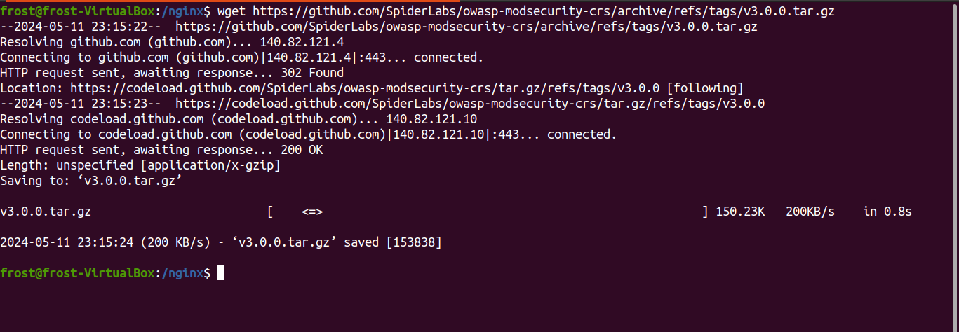

Extract the source code in Nginx directory

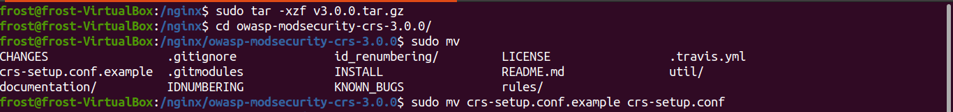

### Step 2: Include CRS rules

Include the crs-setup.conf in the Nginx configuration file as a modsecurity_rules_file

Do the same for other configuration files that end with ‘.conf’ in the directory owasp-modsecurity-crs-3.0.0/rules/

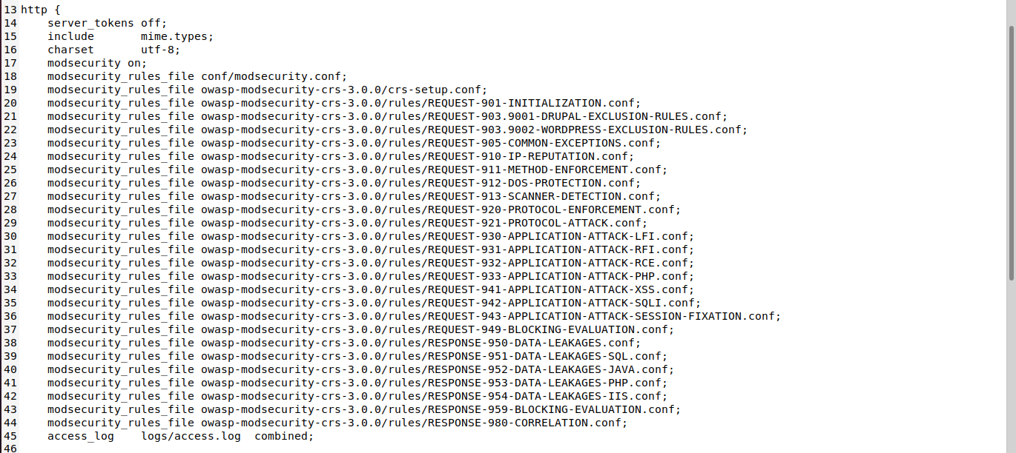

**Setting up grafana monitoring tool**

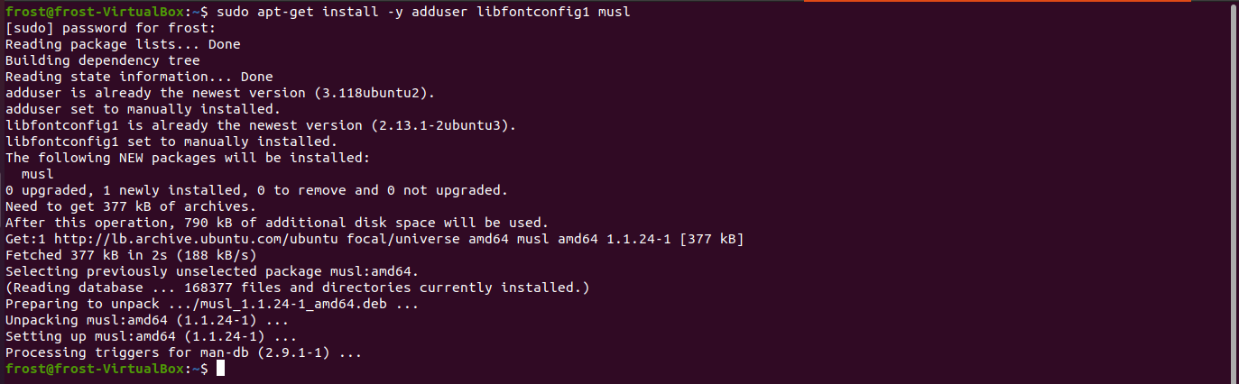

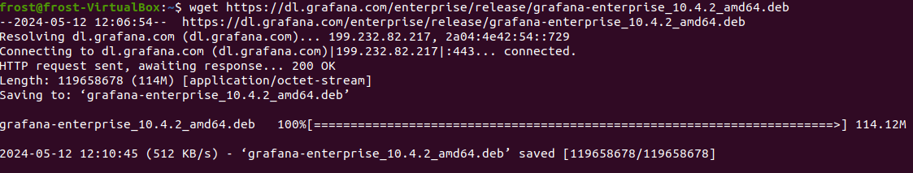

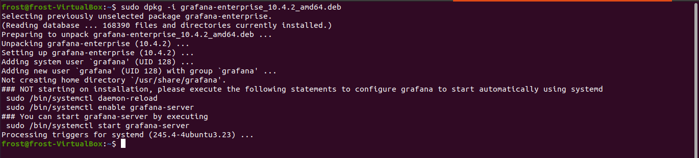

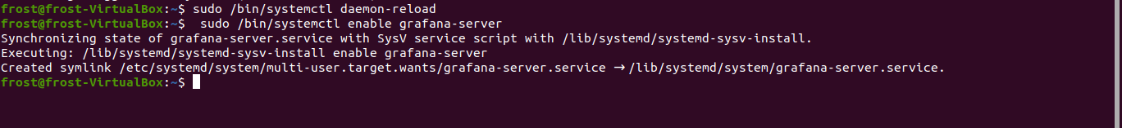

**Enter http://localhost:3000/**

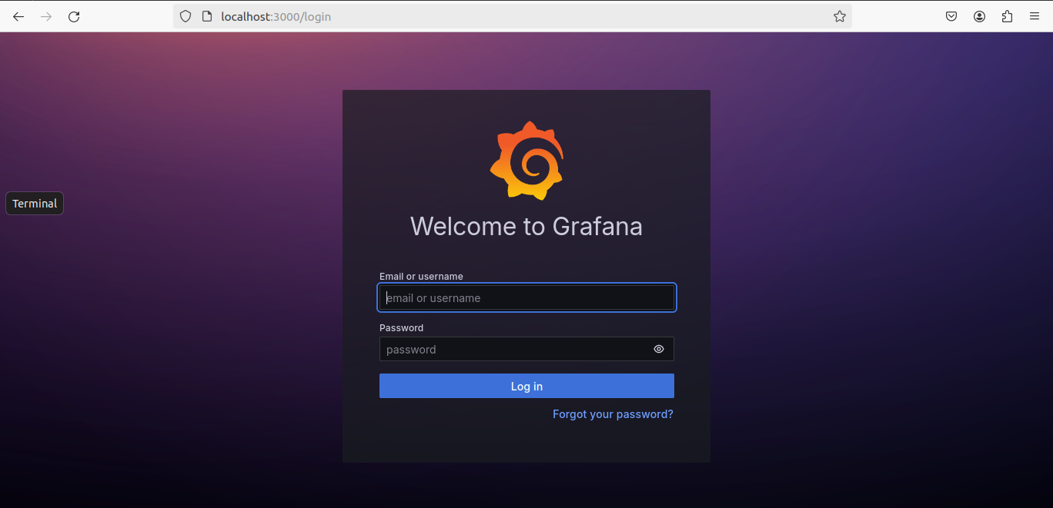

**Default username: “admin”**

**Default password: “admin”**

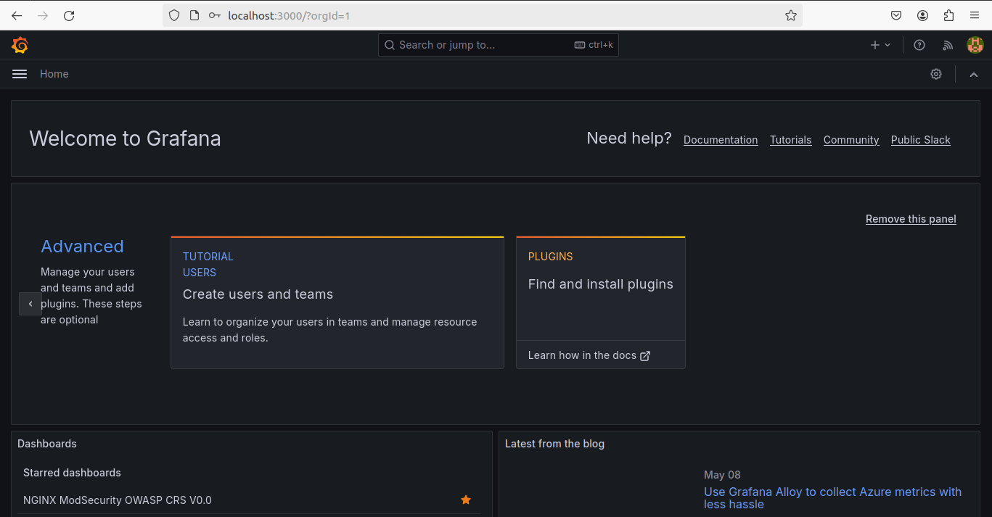

**Installing Prometheus**

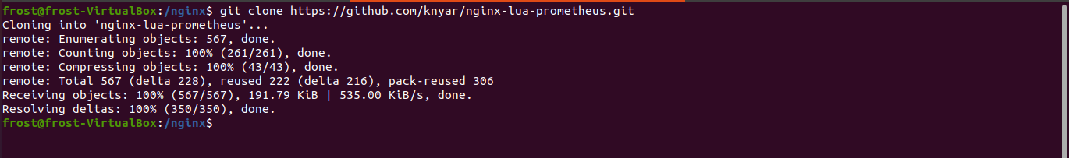

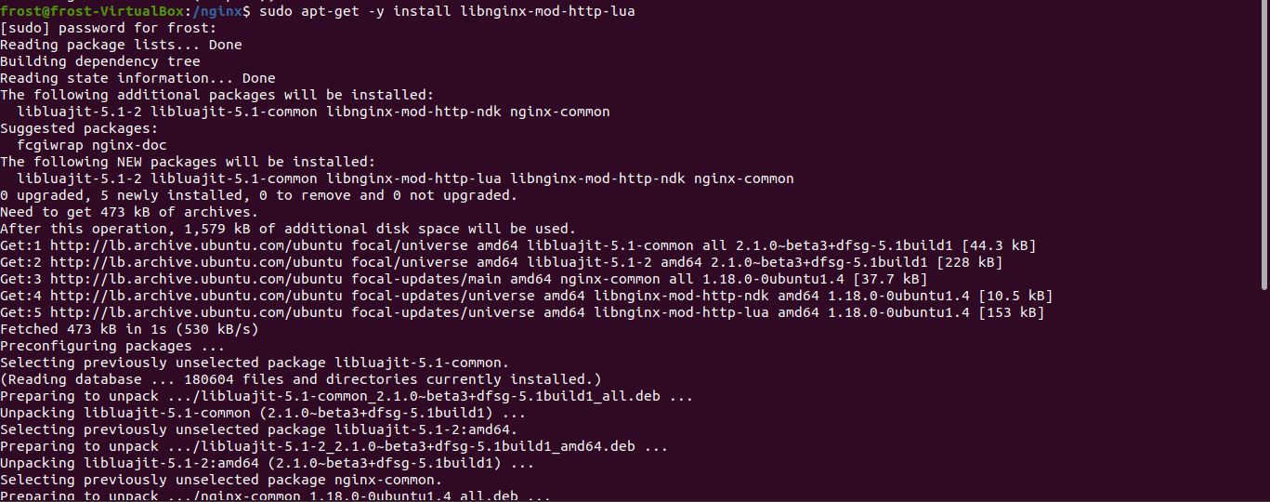

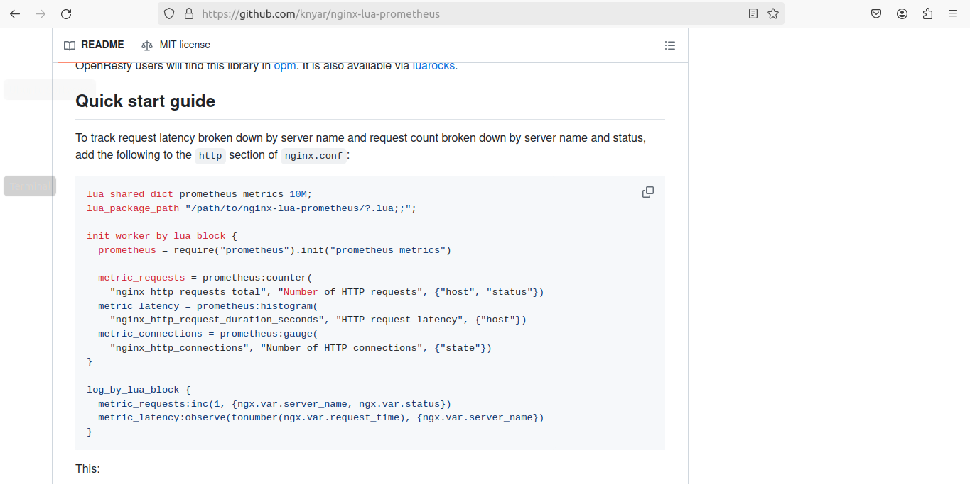

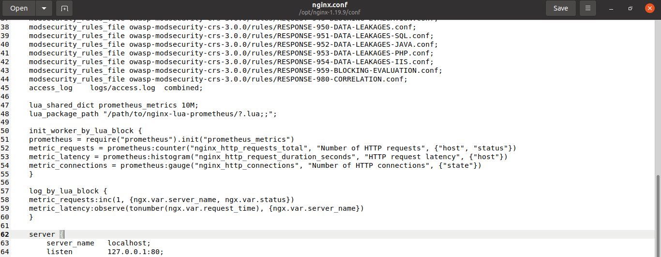

**Change this path to the directory where Prometheus is installed**

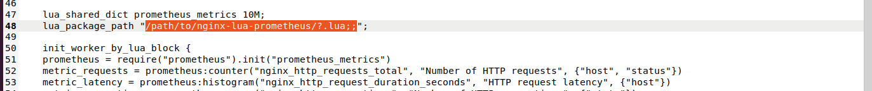

**Find the path of module installed**



**Load the module manually**

